A

**SRS DOCUMENTATION**

On

# MUSIC SHOP MANAGEMENT SYSTEM

Submitted

In partial fulfilment of requirement for the degree of

**Bachelor of technology**

**In**

**computer science and engineering**

Submitted by:

**MOHD SUHAIB KHAN(1902250100086)**

**NIKHIL SHARMA(1902250100092)**



# Department of Computer Science and Engineering

# Accurate Institute Of Management and Technology, Greater Noida

***DR. A.P.J. ABDUL KALAM TECHNICAL UNIVERSITY, LUCKNOW,***

***UTTAR PRADESH , JUN 2022***

***TABLE OF CONTENT:***

Declaration

Certificate

Acknowledgement

# Abstract

Introduction

Related Research

Implementation

Approach

Reference

Appendix

Organizational Issues

Technologies

User Manual

Test Scenarios

Technologies and Tools

USAGES OF PROGRAMMING LANGUAGE:

[SOME INTERESTING FACTS ABOUT C++:](https://www.geeksforgeeks.org/interesting-facts-about-c/)

Header files used

Code

Output

Future Scope

Conclusion

Bibliography

***List of figures:***

***Figure 1.1***  use of case diagram

***Figure 1.2***  *use of* E-R diagram

***Figure 1.3*** *use of* UML diagram

***Figure 1.4*** *Main Menu*

***Figure 1.5*** Enter Password to login(or continue).

***Figure 1.6*** New Costumer Details Entry

***Figure 1.7*** if purchased something then

***Figure 1.8*** Guitar Section

***Figure 1.9*** Acoustic Guitar Section

***Figure 1.10*** Bass Guitar Section

***Figure 1.11*** Classical Guitar

***Figure 1.12*** Electric Guitar

***Figure 1.13*** Keyboard Section

***Figure 1.14*** Tabla Section

***Figure 1.15*** Harmonium Section

***Figure 1.16*** Ukulele

***Figure 1.17*** Trumpet

***Figure 1.18*** Sexophone

***Figure 1.19*** Purchased Items Cash Memo

***Figure 1.20*** Existing Customer (if record found then purchase otherwise register 1st)

***Figure 1.21*** Search a Customer Details.

***Figure 1.22*** Delete a Customer Record.

***Figure 1.23*** Update a Customer details

***Figure 1.24*** Quantity of Items Available.

***Figure 1.25*** Exit

DECLARATION

I hereby declare that this submission is our own work and that to the best of our knowledge and beliefs. It contains no material previously published or written by neither any person nor material which to a substantial extent has been accepted for the award of any other degree or diploma of the university or other institute of higher learning, except where due acknowledgement has been made in the text.

*Name: MOHD SUHAIB KHAN*

*Roll no.:1902250100086*

*Date:9/12/2022*

*Name: NIKHIL SHARMA*

*Roll no:1902250100092*

*Date:9/12/2022*

CERTIFICATE

This is to certify that Project report entitled “Music shop management system in c++”, submitted by Mohd Suhaib khan , Nikhil sharma for partial fulfilment of the requirement for the award of degree Bachelors of Technology in Department of Computer Science & Engineering of Dr.A.P.J Abdul Kalam University, Lucknow is a record of the candidates’ own work carried out by them under my supervision. The matter embodied in this report is original and has not been submitted for the award of any other degree.

**Date:** 9.12.2022  **Supervisor:** ASHISH JAIN SIR

ACKNOWLEDGEMENT

In completing this project, we have been fortunate enough to have help, support and encouragement from many people. I would like to acknowledge them for their cooperation.

Firstly, we would like to thank MR ASHISH JAIN SIR from Department of Computer Science & Engineering, A.I.M.T for guiding us through each and every step of the process with knowledge and support. His thoughts have been a constant source of inspiration for us.

We would also like to acknowledge the contribution of all faculty members of the department for their kind assistance, suggestions and cooperation throughout the development of the project.

Finally, we would like to thank our classmates for the encouragement and help during the project.

*Name: MOHD SUHAIB KHAN*

*Roll no.:1902250100086*

*Date:9/12/2022*

*Name: NIKHIL SHARMA*

*Roll no:1902250100092*

*Date:9/12/2022*

1. **ABSTRACT:**

*This document presents the issues of the C++ project entitled ’Music store’. Its aim is to formally describe the phases of the design and development. The result is a database which enables the clerks and the manager of the Music store to manage the information of customer, musical instrument and its quantity.*

# INTRODUCTION:

The aim of this project is the development of a sample centralized relational Music store program.

This application has to store information of customers, musical instrument and its quantity.

In this context the functionality is to update, remove and insert records for the different entities.

The clerk of the databases must be able to fulfill the wishes of the customer.

These wishes include finding the right instrument and ordering the desired instrument.

This project team decided to implement the core functionality first and later to attach additional functions.

**The Core functionality is:**

1. Add, delete and update Customer information
2. Quantity of Musical instrument.

Additional functionality has to be integrated in an easy way. One can consider the fact that the type of organization we are dealing with can be thought of as being a “virtual” type of organization. One can extend the idea of this single organization to be related to other organization in the field as well.

These can be organizations that deliver the different products to this organization. In this specific case we modeled only one aspect of this organization which deals with the ordering of cd’s and dvd’s by customers.

If we were to consider this application to be a sub-part of other application in this organization, than we could apply some of the aspects that are presented in Afsarmanesh, et al. (1998). The main purpose is the interrelation and information exchange between the different systems.

**Examples of these additional features can be:**

1. Overviews of the entities Customer, Product and Order.
2. Possibility to arrange the customer information for the manager of the Musical store.
3. This enables the manager to get a greater knowledge about the customers.
4. The customer can choose his/her favorite instruments

***USE CASE Daigram of Music Shop Mgt. System:***

This section illustrates the architecture of the database using an USE CASE Diagram

(UAD) and a Relational Schema Definition. The ERD shows the overall structure and

communication in the database. The Relational Schema Definition describes the tables

to be created in the database.

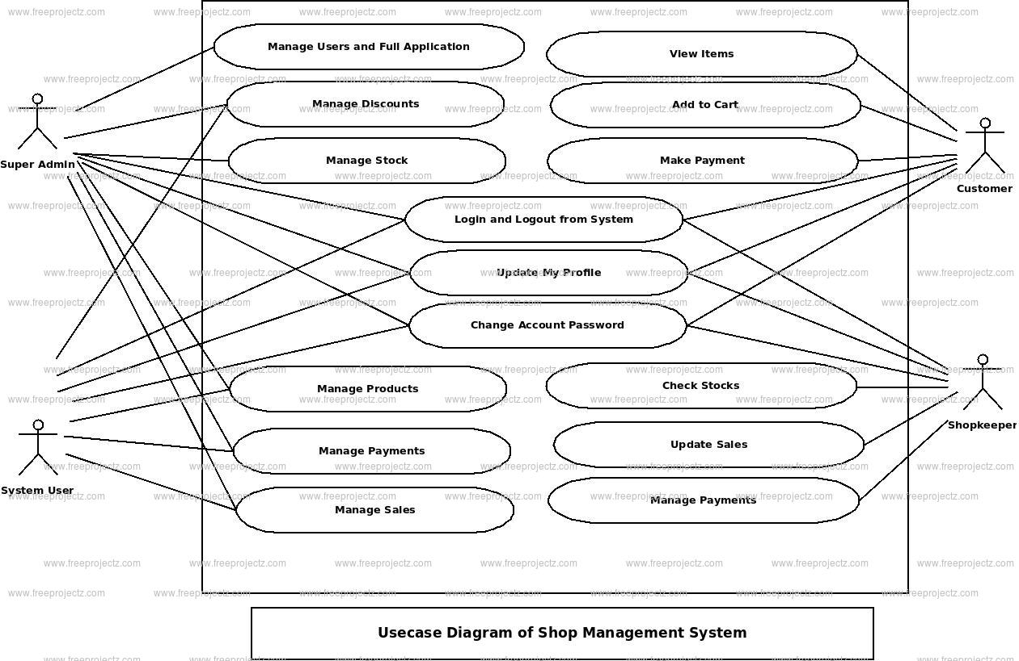

# RELATED RESEARCH:

In this part of the paper we will discuss some of the work that was presented during this course.

We also made a small literature study about some subjects that relates to the project in question.

The main purpose of this part is to show the relation between this project and the subjects that are being researched in the field.

It’s an expansion of the project in question where we aim to relate them in a greater whole. We will not go into the technical details about the subjects discussed here.

We want to merely show the aspect worth considering if we would think about the project as being part of a greater totality.

When considering these solutions and the potential to expand the program and considering it as being part of a greater system.

one must also consider other aspects that relates to the problems one will face when dealing with these types of systems.

Concluding we can note that there are a lot of aspects worth considering when developing a simple program as this one. It may be a small system but if we look at the whole picture we can notice that most organizations consist of these “small applications”.

And it’s the interrelation between these small systems that presents a lot of hardships. Most of the organization would choose for a centralized approach where all the data is gathered into one big txt file, but with the solutions we are presented here one can take a generic approach to the problem in question

# IMPLEMENTATION APPROACH:

The implementation consists of the three following main components.

## Music store application:

The application is implemented in C++. The idea was found from CodeChef.

***ER Daigram of music shop mgt. system:***

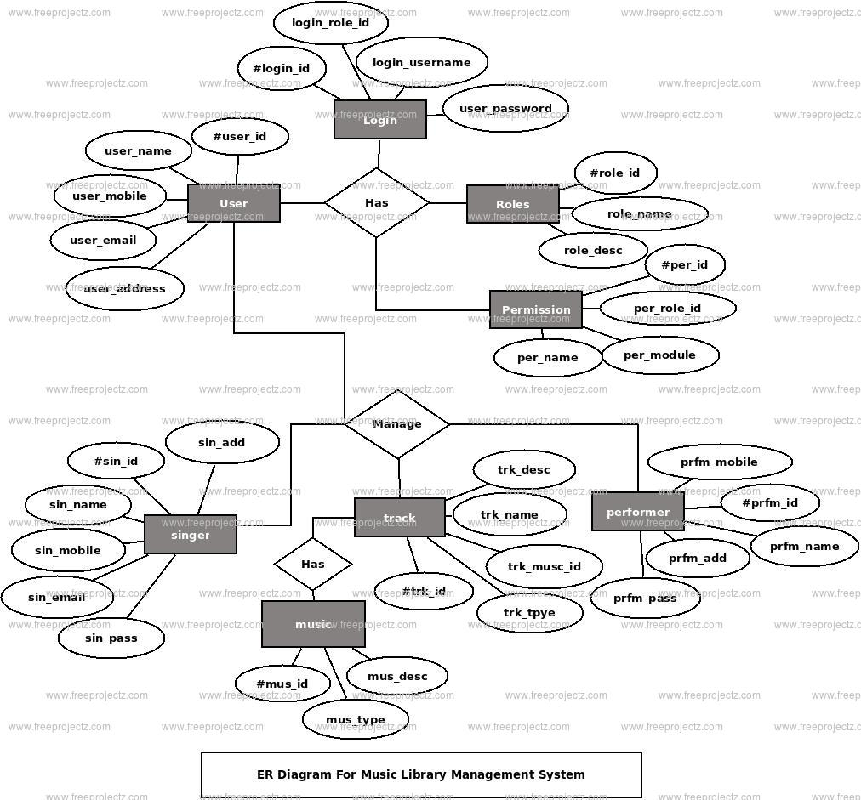

**Presentation of the program structure :**

The program structure as we have decided upon at this moment consists of a set of classes (separately defined in the “class definition file”).

And the ‘core’ program structure which consists of a main routine. That holds a JFrame class.

This (extended) JFrame object holds aside from the separate form objects & menu’s also the calls to the specific (separate) classes and sub-windows/screens.

As well as the objects that are needed to maintain and utilize the database and it’s connection. So the management of the database is kept relatively central in the ‘main’ class of the JFrame Wnd.

This should prevent locking problems in case a separate function or class doesn’t execute properly.

Whenever a class is called or defined a Connection pointer or reference is passed of to the constructor of that particular object so it can manipulate the database for as long as needed and then simply leave the Connection pointer to the garbage collection.

# CONCLUSION:

As stated in the introduction the minimum target at the beginning of this project was to show the core functionalities in a user friendly Console Screen.

During the implementation the team reached their limits and succeeded in replacing these limits several times.

This section will illustrate what the team reached and which problems occurred during the project.

It will describe where the planning was realistic and will also give recommendations for similar or further projects.

The core functionality was reached in the following parts. It is possible to insert a new customer, change the details of a customer and delete a customer.

Also the product part is implemented in the same way. Furthermore the order section is completely implemented.

It is possible to fill in one order for several products. This order also can be changed and deleted.

The team did not succeed in implementing all the musical instruments functionality which was planned. Reasons for that are the lack of experience and time as well as the wish to implement additional features in order to enrich the application from a different angle.

Through this challenge a window was designed in a way that enables the user to simultaneously select products and customer, and view the details of the selected, in the same window

The team created an easy to use program with self-guiding windows. During the process the team was faced with challenges in the problem of saving data. The stored quantity of the instruments reset after the program is executed.

Further development of the project is possible as stated in the introduction in additional features. Due to the problems described in the paragraphs above and the short amount of time, it was not possible to implement all additional features.

It will be interesting to implement more functions in arranging the information of the musical instruments. The built-on architecture that was used supports future developments.

It is advised to similar projects to consider the problems stated in this conclusion. Such projects should plan from the start how to surpass the limitations of their programming language.

This implies a better knowledge of C++ programming itself. They should also follow a strict responsibility policy like in this team. A well planned teamwork is crucial for facing problems during the process.

# REFERENCES:

1. [www.geeksforgreeks.com](http://www.geeksforgreeks.com)
2. [www.codechef.com](http://www.codechef.com)
3. [www.hackerrank.com](http://www.hackerrank.com)
4. [www.hackerearth.com](http://www.hackerearth.com)
5. [www.studytonight.com](http://www.studytonight.com)
6. [www.nptel.com](http://www.nptel.com)
7. [www.tutorialspoint.com](http://www.tutorialspoint.com)

# Appendix:

1. **Technologies:**
   * Turbo C++
   * Notepad++
   * C++ Programming
   * OOPS Concept

# Organizational issues:

This project is part of the course ‘Data Structures’. The class is divided into groups by 4 students. Each team has to develop a different project.

***UML Daigram of Music Shop Mgt. System:***



# User Manual:

**USAGES OF PROGRAMMING LANGUAGE:**

C++ FINDS VARIED USAGE IN APPLICATIONS SUCH AS:OPERATING SYSTEMS & SYSTEMS

PROGRAMMING. E.G. LINUX-BASED OS (UBUNTU ETC.)BROWSERS (CHROME & FIREFOX)GRAPHICS & GAME ENGINES (PHOTOSHOP, BLENDER, UNREAL-ENGINE) DATABASE ENGINES (MYSQL, MONGODB, REDIS ETC.)

[**SOME INTERESTING FACTS ABOUT C++:**](https://www.geeksforgeeks.org/interesting-facts-about-c/)

HERE ARE SOME AWESOME FACTS ABOUT C++ THAT MAY INTEREST YOU:

1. THE NAME OF C++ SIGNIFIES THE EVOLUTIONARY NATURE OF THE CHANGES FROM C. “++” IS THE C INCREMENT OPERATOR.
2. C++ IS ONE OF THE PREDOMINANT LANGUAGES FOR THEDEVELOPMENT OF ALL KIND OF TECHNICAL AND COMMERCIAL SOFTWARE.
3. C++ INTRODUCES OBJECT-ORIENTED PROGRAMMING, NOT PRESENT INC. LIKE OTHER THINGS, C++ SUPPORTS THE FOUR PRIMARY FEATURESOF OOP: ENCAPSULATION, POLYMORPHISM, ABSTRACTION, ANDINHERITANCE.
4. C++ GOT THE OOP FEATURES FROM SIMULA67 PROGRAMMINGLANGUAGE.
5. A FUNCTION IS A MINIMUM REQUIREMENT FOR A C++ PROGRAM TORUN.(AT LEAST MAIN() FUNCTION).

**HEADER FILES USED:**

#include<conio.h>

#include<iostream>

#include<fstream>

#include<cstdlib>

#include<windows.h>

The word **conio.h** stands for **Con** sole- **I**nput **O**utput. The **conio. h** is a non-standard header file used in C and C++programming.

This file contains console input-output functions which are mostly used by MS-DOS compilers. Here we have explained some of the important and most widely used functions of **conio.h** header file.

Some of its most commonly used functions are clrscr, getch, get che, kb hit etc.

**TECHNOLOGIES AND TOOLS:** **Software Used:**

Languages Used : C++ Programming Language

Editor : Notepad++

IDE Used : Turboo-C++ 5.11

**Operating System:** Windows XP Windows 7 Windows 10 Or any other version of windows

**Hardware Used:** CPU configuration

o Processor : Intel Pentium or later

o RAM : 512 MB or later :

* + Hard Disk : 1 Gb Hard Disk Space or more
  + Monitor : Any monitor

## 4,1) Description:

The GUI consists of a Menu showing the following main categories:

Login Page, New Customer, Existing Customer,

Search/Delete/Update Customer Details, and Quantity of

Instruments. The user can view, delete, add or change entries in

customer, order and product.

## Main Menu:

This item includes sub-items ‘New Customer’, ‘Existing Customer’, ‘‘Search a

Record’, ‘Delete a Record’, and ‘Modify a Record ’, ‘Quantity Available. They are

grouped alphabetically to facilitate a convenient search. All attributes of the customers

are listed. It is possible to select one and delete or change the customer details. For

adding a new customer the clerk has to choose the sub-item ‘Add customer’ which

opens a new window. The same is applies to the other sub-item

# *Code:*

# #include<iostream.h>

# #include<conio.h>

# #include<process.h>

# #include<string.h>

# #include<fstream.h>

# #include<stdio.h>

# #include<iomanip.h>

# #include<dos.h>

# /****************************************/

# class consumer

# {

# int cno;

# char cname[20];

# char adress[20];

# long double a;

# float i;

# public:

# //FUNCTION TO ENTER THE VALUES

# public:

# void entry()

# {

# clrscr();

# textcolor(RED);

# gotoxy(32,4);

# cputs("MELODY MUSICAL STORE");

# gotoxy(5,8);

# cputs("Customer ID :");

# gotoxy(5,10);

# cputs("Customer name :");

# gotoxy(5,12);

# cputs("Customer adress :");

# gotoxy(5,14);

# cputs("Costumer Phone number :");

# gotoxy(5,16);

# cputs("Bill no.");

# gotoxy(45,8);

# cin>>cno;

# gotoxy(45,10);

# gets(cname);

# gotoxy(45,12);

# gets(adress);

# gotoxy(45,14);

# cin>>a;

# gotoxy(45,16);

# cin>>i;

# }

# //FUNCTION TO DISPLAY THE VALUES

# void display()

# {

# textcolor(RED);

# cout<<"\n\n";

# gotoxy(5,8);

# cputs("Customer ID :");

# cout<<cno;

# gotoxy(5,10);

# cputs("Customer name :");

# puts(cname);

# gotoxy(5,12);

# cout<<"Customer adress :"<<adress;

# gotoxy(5,14);

# cout<<"Costumer Phone number :"<<a;

# gotoxy(5,20);

# cout<<"Customer Bill number :"<<i<<"\n";

# }

# int rcno()

# {

# return cno;

# }

# }c;

# //FUNCTION TO WRITE THE VALUES

# void write()

# {

# textcolor(RED);

# char ch;

# consumer c;

# fstream f1;

# c.entry();

# f1.open("main1.txt",ios::app);

# cout<<"\n\n\tDO you want to save the record(y/n)\t";

# cin>>ch;

# if(ch=='y')

# {

# f1.write((char*)&c,sizeof(c));

# }

# f1.close();

# }

# //FUNCTION TO READ THE VALUES

# void read()

# {

# consumer c;

# fstream f1;

# f1.open("main1.txt",ios::in);

# while(!f1.eof())

# {

# f1.read((char*)&c,sizeof(c));

# c.display();

# if(f1.eof())

# {

# cout<<"\n\n End of the file reached\n\n";

# }

# }

# f1.close();

# }

# //FUNCTION FOR SEARCHING THE RECORD

# char search()

# {

# textcolor(RED);

# consumer c;

# int rn;

# char found='n';

# ifstream f1("main1.txt",ios::in);

# cout<<"\n\n Enter Customer ID you want to SEARCH :\t";

# cin>>rn;

# while(!f1.eof())

# {

# f1.read((char*)&c,sizeof(c));

# if(c.rcno()==rn)

# {

# c.display();

# found='y';

# break;

# }

# }

# textcolor(RED);

# if(found=='n')

# cout<<"\n\n\tRECORD NOT FOUND!!!!!!!!!!!!!\n"<<endl;

# f1.close();

# return found;

# }

# //FUNCTION TO DELELTE THE RECORD

# void del()

# {

# textcolor(RED);

# ifstream f1("main1.txt",ios::in);

# ofstream f2("temp1.txt",ios::out);

# int rno;

# char found='f',confirm='n';

# cout<<"\n\n Enter Customer ID you want to DELETE :\t";

# cin>>rno;

# while(!f1.eof())

# {

# f1.read((char*)&c,sizeof(c));

# if(c.rcno()==rno)

# {

# c.display();

# found='t';

# cout<<"\n\n Are you sure want to DELETE this record ? (y/n)\t";

# cin>>confirm;

# textcolor(RED);

# if(confirm=='n')

# f2.write((char*)&c,sizeof(c));

# }

# else

# f2.write((char*)&c,sizeof(c));

# }

# if(found=='f')

# cout<<"\n\n\tRECORD NOT FOUND\n";

# f1.close();

# f2.close();

# remove("main1.txt");

# rename("temp1.txt","main1.txt");

# }

# //FUNCTION TO MODIFY THE RECORD

# void update()

# {

# textcolor(RED);

# fstream f1("main1.txt",ios::in | ios::out );

# int rno;

# long pos;

# char found='f';

# cout<<"\n\n Enter the Customer ID you want to MODIFY :\t";

# cin>>rno;

# while(!f1.eof())

# {

# pos=f1.tellg();

# f1.read((char*)&c,sizeof(c));

# if(c.rcno()==rno)

# {

# c.entry();

# f1.seekg(pos);

# f1.write((char*)&c,sizeof(c));

# found='t';

# break;

# }

# }

# textcolor(RED);

# if(found=='f')

# cout<<"\n\n\tRECORD NOT FOUND\n";

# f1.seekg(0);

# textcolor(RED);

# clrscr();

# cout<<"\n Now the file contains\n\n";

# c.display();

# f1.close();

# getch();

# }

# //STARTING OF THE VOID MAIN

# void main()

# {

# unsigned int i,k=0,choice,li,a=0,b=0,c=0,d=0,e=0,f=0,g=0,h=0,j=0,l=0;

# float guia=0,guib=0,guic=0,guie=0,keyb=0,tabl=0,harm=0,ukul=0,trum=0,sexop=0;

# unsigned int gui,agui,bgui,cgui,egui,keybo,tab,har,uku,tru,sexo;

# int m=65,n=50,o=46,p=28,q=42,r=54,s=52,t=40,u=30,v=35;

# float add=0,sum=0;

# char pass[5],opt,yes,et;

# lev1:;

# textcolor(RED);

# clrscr();

# cout<<"\n\n\tPLEASE BE CAREFUL ENTER THE PASSWORD IN SMALL LETTERS\n";

# cout<<"\n\t\tPASSWORD DOES NOT CONTAINS ANY NUMBER\n\n\n";

# cout<<"\n\n\t\t\tEnter your Password : \t";

# pass[0]=getch();

# cout<<"*";

# pass[1]=getch();

# cout<<"*";

# pass[2]=getch();

# cout<<"*";

# pass[3]=getch();

# cout<<"*";

# pass[4]=getch();

# cout<<"*";

# pass[5]='\0';

# cout<<"*";

# cout<<"\n";

# if(strcmp(pass,"hello")==0)

# {

# //LOADING THE PROJECT

# gotoxy(32,13);

# textcolor(LIGHTGREEN);

# cputs("********************");

# gotoxy(32,15);

# cputs("LOADING YOUR PROJECT");

# gotoxy(32,17);

# cputs("********************");

# gotoxy(32,20);

# textcolor(MAGENTA+BLINK);

# cputs("PLEASE WAIT.........");

# textcolor(RED+GREEN);

# delay(500);

# gotoxy(33,21);

# cputs("10 % completed..");

# delay(500);

# gotoxy(33,21);

# cputs("20 % completed...");

# delay(500);

# gotoxy(33,21);

# cputs("30 % completed....");

# delay(500);

# gotoxy(33,21);

# cputs("40 % completed.....");

# delay(500);

# gotoxy(33,21);

# cputs("50 % completed......");

# delay(500);

# gotoxy(33,21);

# cputs("60 % completed.......");

# delay(500);

# gotoxy(33,21);

# cputs("70 % completed........");

# delay(500);

# gotoxy(33,21);

# cputs("80 % completed.........");

# delay(500);

# gotoxy(33,21);

# cputs("90 % completed..........");

# delay(500);

# gotoxy(33,21);

# cputs("100 % completed...........");

# delay(500);

# }

# else

# {

# cout<<"\n\n\t\t\t$$$$$$ Ooop's wrong password $$$$$$\n";

# cout<<"\n\n\t\t\t%%%%%% Please re-enter the password%%%%%%\n";

# getch();

# k++;

# if(k==3)

# {

# cout<<"\n\n\t\tToo Many Attempts\n\n\t\tTry after Sometimes.....";

# getch();

# exit(0);

# }

# getch();

# goto lev1;

# }

# textcolor(BROWN);

# choices:;

# clrscr();

# cout<<"\n%%%%%%%%%%%%%%%%%%%%%%%%%%%%%%%%%%%%%%%%%%%%%%%%%%%%%%%%%%%%%%%%%%%%%%%%%%%%%%%\n";

# cout<<"% WELCOME %\n";

# cout<<"% MELODY MUSICAL STORE %\n";

# cout<<"%%%%%%%%%%%%%%%%%%%%%%%%%%%%%%%%%%%%%%%%%%%%%%%%%%%%%%%%%%%%%%%%%%%%%%%%%%%%%%%\n";

# cout<<"\n\t\t\t **************\n";

# cout<<"\t\t\t * MAIN MENU *\n";

# cout<<"\t\t\t **************\n";

# cout<<" **********************************************************************\n";

# cout<<" *--------------------------------------------------------------------*\n";

# cout<<" *| |*\n";

# cout<<" *| 1. NEW CUSTOMER |*\n";

# cout<<" *| 2. EXISTING CUSTOMER |*\n";

# cout<<" *| 3. SEARCH A RECORD |*\n";

# cout<<" *| 4. DELETE A RECORD |*\n";

# cout<<" *| 5. MOODIFY A RECORD |*\n";

# cout<<" *| 6. QUANTITY AVAILABLE |*\n";

# cout<<" *| 0. EXIT |*\n";

# cout<<" *| |*\n";

# cout<<" *--------------------------------------------------------------------*\n";

# cout<<" **********************************************************************\n";

# cout<<"Enter Your choice : ";

# cin>>choice;

# cout<<"PRESS ANY KEY TO CONTINUE.....";

# getch();

# switch(choice)

# {

# case 1:

# {

# clrscr();

# textcolor(RED);

# cout<<"\n\n\t\t\t MELODY MUSICAL STORE\n";

# cout<<"\n\n\t\t\t COSTUMER INFO \n\n";

# // TO ENTER DETAILS OF COSTUMER

# write();

# //ITEM PURCHASE AND THEIR RATE

# cout<<"\n\nDO YOU WANT TO PURCHASE ANYTHING (Y/N) : ";

# cin>>opt;

# if(opt=='y'||opt=='Y')

# {

# list:;

# clrscr();

# textcolor(BROWN);

# // LIST ITEMS

# cout<<"\n\t\t\t============";

# cout<<"\n\t\t\t|| LIST ||";

# cout<<"\n\t\t\t============\n";

# cout<<" **********************************************************************\n";

# cout<<" *--------------------------------------------------------------------*\n";

# cout<<" *| |*\n";

# cout<<" *| 1. GUITAR |*\n";

# cout<<" *| 2. KEYBOARD |*\n";

# cout<<" *| 3. TABLA |*\n";

# cout<<" *| 4. HARMONIUM |*\n";

# cout<<" *| 5. UKULELE |*\n";

# cout<<" *| 6. TRUMPET |*\n";

# cout<<" *| 7. SEXOPHONE |*\n";

# cout<<" *--------------------------------------------------------------------*\n";

# cout<<" **********************************************************************\n";

# cout<<"\n\nEnter your choics :\t";

# cin>>li;

# switch(li)

# {

# case 1:

# {

# guitar:

# textcolor(BROWN);

# clrscr();

# cout<<"\n\t\t\t===================";

# cout<<"\n\t\t\t|| GUITAR TYPE ||";

# cout<<"\n\t\t\t===================\n";

# cout<<" **********************************************************************\n";

# cout<<" *--------------------------------------------------------------------*\n";

# cout<<" *| |*\n";

# cout<<" *| 1. ACOUSTIC GUITAR |*\n";

# cout<<" *| 2. BASS GUITAR |*\n";

# cout<<" *| 3. CLASSICAL GUITAR |*\n";

# cout<<" *| 4. ELECTRICAL GUITAR |*\n";

# cout<<" *--------------------------------------------------------------------*\n";

# cout<<" **********************************************************************\n";

# cout<<"\n\nEnter your choice :\t";

# cin>>gui;

# switch(gui)

# {

# case 1:

# {

# acoustic:;

# textcolor(BROWN);

# clrscr();

# cout<<"\n\t\t\t=======================";

# cout<<"\n\t\t\t|| ACOUSTIC GUITAR ||";

# cout<<"\n\t\t\t=====================\n";

# cout<<" **********************************************************************\n";

# cout<<" *--------------------------------------------------------------------*\n";

# cout<<" *| ITEMS RATE |*\n";

# cout<<" *| %%%%%%%%%%%%%%%%%%%%%%%%%%%%%%%%%%%%%%%%%%%%%%%%%%%%%%%%%%%%%%%% |*\n";

# cout<<" *| 1. HERTZ HZA-3801E (LINDEN WOOD) 9999/- |*\n";

# cout<<" *| 2. GIVSON G-150 (ROSEWOOD) 4999/- |*\n";

# cout<<" *| 3. HERTZ HZA 4000 EQ (LINDEN WOOD) 8999/- |*\n";

# cout<<" *| 4. GIVSON VENUS (LINDEN WOOD) 5999/- |*\n";

# cout<<" *| 5. YAMAHA F310 GUITAR 9599/- |*\n";

# cout<<" *--------------------------------------------------------------------*\n";

# cout<<" **********************************************************************\n";

# cout<<"\n\nEnter your choice :\t";

# cin>>agui;

# switch(agui)

# {

# case 1:

# guia=9999;

# break;

# case 2:

# guia=4999;

# break;

# case 3:

# guia=8999;

# break;

# case 4:

# guia=5999;

# break;

# case 5:

# guia=9599;

# break;

# case 0:

# goto guitar;

# default:

# textcolor(RED);

# cprintf("OPS!!! WRONG INPUT \nPLEASE CHOOSE AGAIN.....");

# getch();

# goto acoustic;

# }

# a=1;

# goto purchase;

# }

# case 2:

# {

# bass:;

# textcolor(BROWN);

# clrscr();

# cout<<"\n\t\t\t==================";

# cout<<"\n\t\t\t|| BASS GUITAR ||";

# cout<<"\n\t\t\t==================\n";

# cout<<" **********************************************************************\n";

# cout<<" *--------------------------------------------------------------------*\n";

# cout<<" *| ITEMS RATE |*\n";

# cout<<" *| %%%%%%%%%%%%%%%%%%%%%%%%%%%%%%%%%%%%%%%%%%%%%%%%%%%%%%%%%%%%%%%% |*\n";

# cout<<" *| 1. FENDER ELECTRIC BASS GUITAR 95999/- |*\n";

# cout<<" *| 2. GIVSON ELECTRIC BASS GUITAR 13999/- |*\n";

# cout<<" *--------------------------------------------------------------------*\n";

# cout<<" **********************************************************************\n";

# cout<<"\n\nEnter your choice :\t";

# cin>>bgui;

# switch(bgui)

# {

# case 1:

# guib=95999;

# break;

# case 2:

# guib=13999;

# break;

# case 0:

# goto guitar;

# default:

# textcolor(RED);

# cprintf("OPS!!! WRONG INPUT \nPLEASE CHOOSE AGAIN.....");

# getch();

# goto bass;

# }

# b=1;

# goto purchase;

# }

# case 3:

# {

# classical:;

# textcolor(BROWN);

# clrscr();

# cout<<"\n\t\t\t========================";

# cout<<"\n\t\t\t|| CLASSICAL GUITAR ||";

# cout<<"\n\t\t\t========================\n";

# cout<<" **********************************************************************\n";

# cout<<" *--------------------------------------------------------------------*\n";

# cout<<" *| ITEMS RATE |*\n";

# cout<<" *| %%%%%%%%%%%%%%%%%%%%%%%%%%%%%%%%%%%%%%%%%%%%%%%%%%%%%%%%%%%%%%%% |*\n";

# cout<<" *| 1. YAMAHA C4OM 7999/- |*\n";

# cout<<" *| 2. VAULT EC397OSK 16999/- |*\n";

# cout<<" *| 3. ALVAREZ RC26 16999/- |*\n";

# cout<<" *| 4. CORT AC250CF 27999/- |*\n";

# cout<<" *| 5. FENDER ECS80 NS 13599/- |*\n";

# cout<<" *| 6. ORTEGA R122SN 14999/- |*\n";

# cout<<" *--------------------------------------------------------------------*\n";

# cout<<" **********************************************************************\n";

# cout<<"\n\nEnter your choice :\t";

# cin>>cgui;

# switch(cgui)

# {

# case 1:

# guic=7999;

# break;

# case 2:

# guic=16999;

# break;

# case 3:

# guic=16999;

# break;

# case 4:

# guic=27999;

# break;

# case 5:

# guic=13599;

# break;

# case 6:

# guic=14999;

# break;

# case 0:

# goto guitar;

# default:

# textcolor(RED);

# cprintf("OPS!!! WRONG INPUT \nPLEASE CHOOSE AGAIN.....");

# getch();

# goto classical;

# }

# c=1;

# goto purchase;

# }

# case 4:

# {

# electric:;

# textcolor(BROWN);

# clrscr();

# cout<<"\n\t\t\t=========================";

# cout<<"\n\t\t\t|| ELECTRIC GUITAR ||";

# cout<<"\n\t\t\t=========================\n";

# cout<<" **********************************************************************\n";

# cout<<" *--------------------------------------------------------------------*\n";

# cout<<" *| ITEMS RATE |*\n";

# cout<<" *| %%%%%%%%%%%%%%%%%%%%%%%%%%%%%%%%%%%%%%%%%%%%%%%%%%%%%%%%%%%%%%%% |*\n";

# cout<<" *| 1. VAULT ST1 7999/- |*\n";

# cout<<" *| 2. FRENDER SQUIER MMSTRATOCASTER 11999/- |*\n";

# cout<<" *| 3. CORT X100 14999/- |*\n";

# cout<<" *| 4. ESP LTD EC 256FM 33999/- |*\n";

# cout<<" *| 5. IBANEZ SA260FM 31999/- |*\n";

# cout<<" *| 6. JACKSON JS12 19999/- |*\n";

# cout<<" *--------------------------------------------------------------------*\n";

# cout<<" **********************************************************************\n";

# cout<<"\n\nEnter your choice :\t";

# cin>>egui;

# switch(egui)

# {

# case 1:

# guie=7999;

# break;

# case 2:

# guie=11999;

# break;

# case 3:

# guie=14999;

# break;

# case 4:

# guie=33999;

# break;

# case 5:

# guie=31999;

# break;

# case 6:

# guie=19999;

# break;

# case 0:

# goto guitar;

# default:

# cout<<"OPS!!! WRONG INPUT \nPLEASE CHOOSE AGAIN.....";

# getch();

# goto electric;

# }

# d=1;

# goto purchase;

# }

# case 0:

# goto list;

# default:

# textcolor(RED);

# cout<<"OPS!!! WRONG INPUT \nPLEASE CHOOSE AGAIN.....";

# getch();

# goto guitar;

# }

# }

# case 2:

# {

# keyboard:;

# textcolor(BROWN);

# clrscr();

# cout<<"\n\t\t\t================";

# cout<<"\n\t\t\t|| KEYBOARD ||";

# cout<<"\n\t\t\t================\n";

# cout<<" **********************************************************************\n";

# cout<<" *--------------------------------------------------------------------*\n";

# cout<<" *| ITEMS RATE |*\n";

# cout<<" *| %%%%%%%%%%%%%%%%%%%%%%%%%%%%%%%%%%%%%%%%%%%%%%%%%%%%%%%%%%%%%%%% |*\n";

# cout<<" *| 1. CASIO CTK 2550 7599/- |*\n";

# cout<<" *| 2. CASIO SA 78 3499/- |*\n";

# cout<<" *| 3. CASIO CTK 3500 9999/- |*\n";

# cout<<" *| 4. YAMAHA PSR F 51 10999/- |*\n";

# cout<<" *| 5. YAMAHA PSS F30 4999/- |*\n";

# cout<<" *| 6. TRINITY PA 51X 4999/- |*\n";

# cout<<" *--------------------------------------------------------------------*\n";

# cout<<" **********************************************************************\n";

# cout<<"\n\nEnter your choice :\t";

# cin>>keybo;

# switch(keybo)

# {

# case 1:

# keyb=7599;

# break;

# case 2:

# keyb=3499;

# break;

# case 3:

# keyb=9999;

# break;

# case 4:

# keyb=10999;

# break;

# case 5:

# keyb=4999;

# break;

# case 6:

# keyb=4999;

# break;

# case 0:

# goto list;

# default:

# textcolor(RED);

# cprintf("OPS!!! WRONG INPUT \nPLEASE CHOOSE AGAIN.....");

# getch();

# goto keyboard;

# }

# e=1;

# goto purchase;

# }

# case 3:

# {

# tabla:;

# textcolor(BROWN);

# clrscr();

# cout<<"\n\t\t\t=============";

# cout<<"\n\t\t\t|| TABLA ||";

# cout<<"\n\t\t\t=============\n";

# cout<<" **********************************************************************\n";

# cout<<" *--------------------------------------------------------------------*\n";

# cout<<" *| ITEMS RATE |*\n";

# cout<<" *| %%%%%%%%%%%%%%%%%%%%%%%%%%%%%%%%%%%%%%%%%%%%%%%%%%%%%%%%%%%%%%%% |*\n";

# cout<<" *| 1. AKSHAR TABLA MART 5999/- |*\n";

# cout<<" *| 2. R R MUSICAL TABLA 3499/- |*\n";

# cout<<" *| 3. SG MUSICAL TABLA 4999/- |*\n";

# cout<<" *| 4. DEV MUSICAL TABLA 10999/- |*\n";

# cout<<" *| 5. BABA SURJAN SINGH TABLA 3999/- |*\n";

# cout<<" *--------------------------------------------------------------------*\n";

# cout<<" **********************************************************************\n";

# cout<<"\n\nEnter your choice :\t";

# cin>>tab;

# switch(tab)

# {

# case 1:

# tabl=5999;

# break;

# case 2:

# tabl=3499;

# break;

# case 3:

# tabl=4999;

# break;

# case 4:

# tabl=10999;

# break;

# case 5:

# tabl=3999;

# break;

# case 0:

# goto list;

# default:

# textcolor(RED);

# cprintf("OPS!!! WRONG INPUT \nPLEASE CHOOSE AGAIN.....");

# getch();

# goto tabla;

# }

# f=1;

# goto purchase;

# }

# case 4:

# {

# harmonium:;

# textcolor(BROWN);

# clrscr();

# cout<<"\n\t\t\t=================";

# cout<<"\n\t\t\t|| HARMONIUM ||";

# cout<<"\n\t\t\t=================\n";

# cout<<" **********************************************************************\n";

# cout<<" *--------------------------------------------------------------------*\n";

# cout<<" *| ITEMS RATE |*\n";

# cout<<" *| %%%%%%%%%%%%%%%%%%%%%%%%%%%%%%%%%%%%%%%%%%%%%%%%%%%%%%%%%%%%%%%% |*\n";

# cout<<" *| 1. JV MUSICALS HAR003 HARMONIUM 7599/- |*\n";

# cout<<" *| 2. RAJA HAR_1 440 HARMONIUM 6999/- |*\n";

# cout<<" *| 3. MMB 9 STOPPER HARMONIUM 18599/- |*\n";

# cout<<" *| 4. JSR SH1297 HARMONIUM 9999/- |*\n";

# cout<<" *| 5. PAL MUSIC HOUSE HARMONIUM 18599/- |*\n";

# cout<<" *--------------------------------------------------------------------*\n";

# cout<<" **********************************************************************\n";

# cout<<"\n\nEnter your choice :\t";

# cin>>har;

# switch(har)

# {

# case 1:

# harm=7599;

# break;

# case 2:

# harm=6999;

# break;

# case 3:

# harm=18599;

# break;

# case 4:

# harm=9999;

# break;

# case 5:

# harm=18599;

# break;

# case 0:

# goto list;

# default:

# textcolor(RED);

# cprintf("OPS!!! WRONG INPUT \nPLEASE CHOOSE AGAIN.....");

# getch();

# goto harmonium;

# }

# g=1;

# goto purchase;

# }

# case 5:

# {

# ukulele:;

# textcolor(BROWN);

# clrscr();

# cout<<"\n\t\t\t===============";

# cout<<"\n\t\t\t|| UKULELE ||";

# cout<<"\n\t\t\t===============\n";

# cout<<" **********************************************************************\n";

# cout<<" *--------------------------------------------------------------------*\n";

# cout<<" *| ITEMS RATE |*\n";

# cout<<" *| %%%%%%%%%%%%%%%%%%%%%%%%%%%%%%%%%%%%%%%%%%%%%%%%%%%%%%%%%%%%%%%% |*\n";

# cout<<" *| 1. KADENCE CONCERT UKULELE 3599/- |*\n";

# cout<<" *| 2. HERTZ SOPRANO UKULELE 4599/- |*\n";

# cout<<" *| 3. ZABEL ZBL U21 BRN SOPRANO UKULELE 2499/- |*\n";

# cout<<" *| 4. PLUSE SOPRANO UKULELE 3999/- |*\n";

# cout<<" *--------------------------------------------------------------------*\n";

# cout<<" **********************************************************************\n";

# cout<<"\n\nEnter your choice :\t";

# cin>>uku;

# switch(uku)

# {

# case 1:

# ukul=3599;

# break;

# case 2:

# ukul=4599;

# break;

# case 3:

# ukul=2499;

# break;

# case 4:

# ukul=3999;

# break;

# case 0:

# goto list;

# default:

# textcolor(RED);

# cprintf("OPS!!! WRONG INPUT \nPLEASE CHOOSE AGAIN.....");

# getch();

# goto ukulele;

# }

# h=1;

# goto purchase;

# }

# case 6:

# {

# trumpet:;

# textcolor(BROWN);

# clrscr();

# cout<<"\n\t\t\t===============";

# cout<<"\n\t\t\t|| TRUMPET ||";

# cout<<"\n\t\t\t===============\n";

# cout<<" **********************************************************************\n";

# cout<<" *--------------------------------------------------------------------*\n";

# cout<<" *| ITEMS RATE |*\n";

# cout<<" *| %%%%%%%%%%%%%%%%%%%%%%%%%%%%%%%%%%%%%%%%%%%%%%%%%%%%%%%%%%%%%%%% |*\n";

# cout<<" *| 1. NASIR ALI NACIT BB TRUMPET 3599/- |*\n";

# cout<<" *| 2. KANHA HUB BB TRUMPET 3599/- |*\n";

# cout<<" *| 3. JAIBHARAT MUSICAL BB TRUMPET 4999/- |*\n";

# cout<<" *| 4. SEIMENTO STR 54512 PRO 5999/- |*\n";

# cout<<" *--------------------------------------------------------------------*\n";

# cout<<" **********************************************************************\n";

# cout<<"\n\nEnter your choice :\t";

# cin>>tru;

# switch(tru)

# {

# case 1:

# trum=3599;

# break;

# case 2:

# trum=3599;

# break;

# case 3:

# trum=4999;

# break;

# case 4:

# trum=5999;

# break;

# case 0:

# goto list;

# default:

# textcolor(RED);

# cprintf("OPS!!! WRONG INPUT \nPLEASE CHOOSE AGAIN.....");

# getch();

# goto trumpet;

# }

# l=1;

# goto purchase;

# }

# case 7:

# {

# sexophone:;

# textcolor(BROWN);

# clrscr();

# cout<<"\n\t\t\t=================";

# cout<<"\n\t\t\t|| SEXOPHONE ||";

# cout<<"\n\t\t\t=================\n";

# cout<<" **********************************************************************\n";

# cout<<" *--------------------------------------------------------------------*\n";

# cout<<" *| ITEMS RATE |*\n";

# cout<<" *| %%%%%%%%%%%%%%%%%%%%%%%%%%%%%%%%%%%%%%%%%%%%%%%%%%%%%%%%%%%%%%%% |*\n";

# cout<<" *| 1. KADENCE KXC KAD SAX KCX SEXOPHONE 41999/- |*\n";

# cout<<" *| 2. SEIMENTO TUNED STR 00714258 SEXOPHONE 11999/- |*\n";

# cout<<" *| 3. RAGHAV ASSOCIATES ALTO SEXOPHONE 9999/- |*\n";

# cout<<" *| 4. INFINITY ALTO LS S01 SEXOPHONE 39999/- |*\n";

# cout<<" *| 5. ROLAND AE 10 DIGITAL SEXOPHONE 82999/- |*\n";

# cout<<" *--------------------------------------------------------------------*\n";

# cout<<" **********************************************************************\n";

# cout<<"\n\nEnter your choice :\t";

# cin>>sexo;

# switch(sexo)

# {

# case 1:

# sexop=41999;

# break;

# case 2:

# sexop=11999;

# break;

# case 3:

# sexop=9999;

# break;

# case 4:

# sexop=39999;

# break;

# case 5:

# sexop=82999;

# break;

# case 0:

# goto list;

# default:

# textcolor(RED);

# cprintf("OPS!!! WRONG INPUT \nPLEASE CHOOSE AGAIN.....");

# getch();

# goto sexophone;

# }

# j=1;

# goto purchase;

# }

# case 0:

# goto choices;

# default:

# textcolor(RED);

# cprintf("OPS!!! WRONG INPUT \nPLEASE CHOOSE AGAIN.....");

# getch();

# goto list;

# }

# }

# else

# goto choices;

# purchase:;

# textcolor(RED);

# cout<<"\n\tDO you want to purchase more(y/n)";

# cin>>yes;

# if(yes=='y')

# {

# clrscr();

# goto list;

# }

# else

# {

# clrscr();

# goto cash;

# }

# cash:;

# clrscr();

# textcolor(RED);

# cout<<"\n\n\t\t\t\t MELODY MUSICAL STORE\n";

# cout<<"\n\t\t\t\t CASH MEMO\n";

# cout<<"\n";

# //TO DISPLAY THE CASH MEMO

# add=a+b+c+d+e+f+g+h+j+l;

# sum=guia+guib+guic+guie+keyb+tabl+harm+ukul+trum+sexop;

# textcolor(RED);

# cout<<"\n";

# cout<<"===============================================================================";

# cout<<"\nITEMS" <<setw(40)<<"QUANTITY"<<setw(35)<<"PRICE(Rs.)";

# cout<<"===============================================================================";

# if(a>0)

# cout<<"\n\nGUITAR (A)" <<setw(33)<<a<<setw(28)<<"Rs."<<guia;

# if(b>0)

# cout<<"\n\nGUITAR (B)" <<setw(33)<<b<<setw(28)<<"Rs."<<guib;

# if(c>0)

# cout<<"\n\nGUITAR (C)" <<setw(33)<<c<<setw(28)<<"Rs."<<guic;

# if(d>0)

# cout<<"\n\nGUITAR (E)" <<setw(33)<<d<<setw(28)<<"Rs."<<guie;

# if(e>0)

# cout<<"\n\nKEYBOARD" <<setw(35)<<e<<setw(28)<<"Rs."<<keyb;

# if(f>0)

# cout<<"\n\TABLA" <<setw(38)<<f<<setw(28)<<"Rs."<<tabl;

# if(g>0)

# cout<<"\n\nHARMONIUM" <<setw(34)<<g<<setw(28)<<"Rs."<<harm;

# if(h>0)

# cout<<"\n\nUKULELE" <<setw(36)<<h<<setw(28)<<"Rs."<<ukul;

# if(l>0)

# cout<<"\n\nTRUMPET" <<setw(36)<<l<<setw(28)<<"Rs."<<trum;

# if(j>0)

# cout<<"\n\nSEXOPHONE" <<setw(34)<<j<<setw(28)<<"Rs."<<sexop;

# cout<<"\n===============================================================================";

# cout<<"\nTOTAL:"<<setw(38)<<add<<setw(27)<<"Rs."<<sum;

# m-=a;

# a=0;

# n-=b;

# b=0;

# o-=c;

# c=0;

# p-=d;

# d=0;

# q-=e;

# e=0;

# r-=f;

# f=0;

# s-=g;

# g=0;

# t-=h;

# h=0;

# v-=j;

# j=0;

# u-=l;

# l=0;

# sum=0;

# add=0;

# textcolor(RED);

# cout<<"\n\n\t";

# cprintf("THANK YOU . VISIT US AGAIN");

# cout<<"\n\n\n\t";

# cprintf("THANK YOU FOR USING OUR SERVICE");

# cout<<"\n\n";

# getch();

# goto choices;

# }

# case 2:

# {

# textcolor(RED);

# char found;

# clrscr();

# found=search();

# getch();

# if(found=='n')

# {

# goto choices;

# }

# else

# {

# cout<<"\n\nDO YOU WANT TO PURCHASE ANYTHING (Y/N) : ";

# cin>>opt;

# if(opt=='y'||opt=='Y')

# {

# goto list;

# }

# else

# goto exi;

# }

# }

# case 3:

# //TO SEARCH THE RECORDS

# clrscr();

# search();

# getch();

# goto choices;

# case 4:

# //TO DELETE THE RECORDS

# clrscr();

# del();

# getch();

# goto choices;

# case 5:

# //TO MODIFY THE RECORDS

# clrscr();

# update();

# getch();

# goto choices;

# case 6:

# //TO DISPLAY THE QUANTITY AVAILABLE IN THE SHOP

# textcolor(BROWN);

# clrscr();

# cout<<"\n\t\t\tItems Avaliable in shop.\n\n\n";

# cout<<"===============================================================================";

# cout<<"\nITEMS" <<setw(40)<<"QUANTITY";

# cout<<"\n===============================================================================";

# cout<<"\n\nGUITAR (ACOUSTIC)" <<setw(28)<<m;

# cout<<"\n\nGUITAR (BASS)" <<setw(32)<<n;

# cout<<"\n\nGUITAR (CLASSICAL)" <<setw(27)<<o;

# cout<<"\n\nGUITAR (ELECTRICAL)" <<setw(26)<<p;

# textcolor(BROWN);

# cout<<"\n\nKEYBOARD" <<setw(37)<<q;

# cout<<"\n\nTABLA" <<setw(40)<<r;

# cout<<"\n\nHARMONIUM" <<setw(36)<<s;

# cout<<"\n\nUKULELE" <<setw(38)<<t;

# cout<<"\n\nTRUMPET" <<setw(38)<<u;

# cout<<"\n\nSEXOPHONE" <<setw(36)<<v;

# cout<<"\n*******************************************************************************";

# getch();

# goto choices;

# case 0:

# //TO EXIT FROM THE PROGRAM

# exi:

# textcolor(RED);

# clrscr();

# cout<<"\n\n\n\t\tARE YOU SURE TO EXIT FROM THE PROGRAM\t";

# cin>>et;

# if(et=='y')

# {

# goto ex;

# }

# else

# {

# goto choices;

# }

# ex:;

# clrscr();

# textcolor(RED);

# sleep(1);

# clrscr();

# gotoxy(35,10);

# cout<<" THANKS ";

# sleep(1);

# clrscr();

# gotoxy(35,20);

# cout<<" THANKS ";

# sleep(1);

# clrscr();

# gotoxy(28,30);

# cout<<" THANK YOU FOR USING THE PROJECT\n\n\n\n ";

# gotoxy(35,35);

# textcolor(GREEN+BLINK);

# gotoxy(35,25);

# textcolor(RED+YELLOW);

# delay(1000);

# cputs("HAVE A NICE DAY");

# gotoxy(45,45);

# textcolor(YELLOW+BLINK);

# cputs("Press ENTER to EXIT.......");

# getch();

# exit(0);

# default:

# textcolor(RED);

# cprintf("OPS!!! WRONG INPUT \nPLEASE CHOOSE AGAIN.....");

# getch();

# goto choices;

# }

# }

***OUTPUT:***

## Description

The GUI consists of a Menu showing the following main categories: Login Page, New Customer, Existing Customer, Search/Delete/Update Customer Details, and Quantity of Instruments. The user can view, delete, add or change entries in customer, order and product.

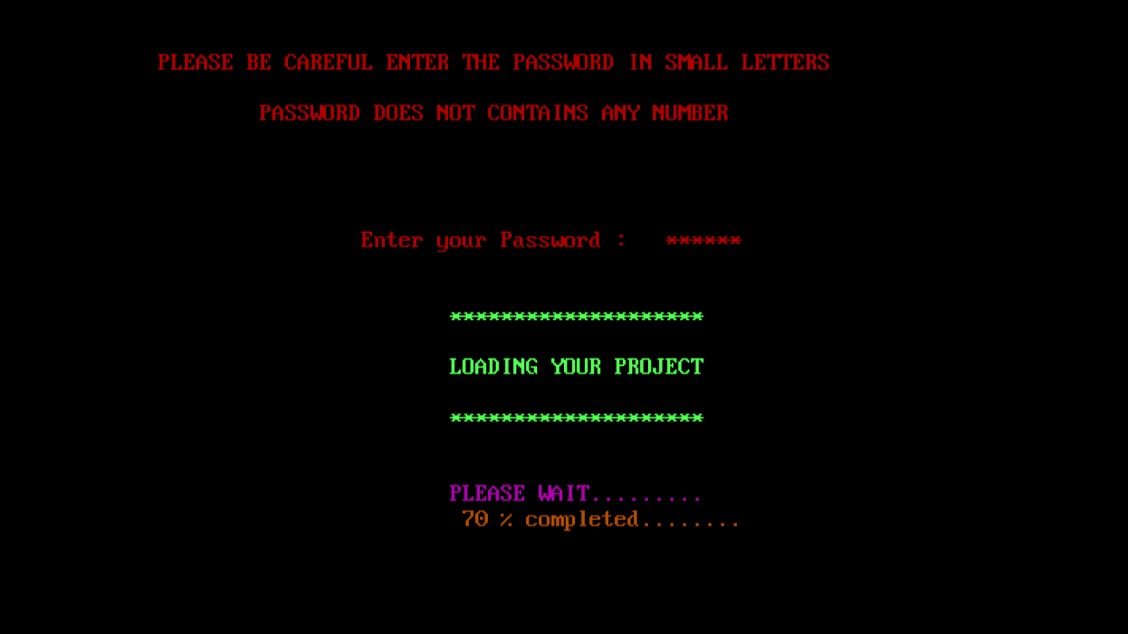

FIG: Enter Password to login(or continue).

## 

## Main Menu

This item includes sub-items ‘New Customer’, ‘Existing Customer’, ‘Search a Record’, ‘Delete a Record’, and ‘Modify a Record ’, ‘Quantity Available.

They are grouped alphabetically to facilitate a convenient search. All attributes of the customers are listed.

It is possible to select one and delete or change the customer details. For adding a new customer the clerk has to choose the sub-item ‘Add customer’ which opens a new window. The same is applies to the other sub-item.

## FIG: Main Menu

## 

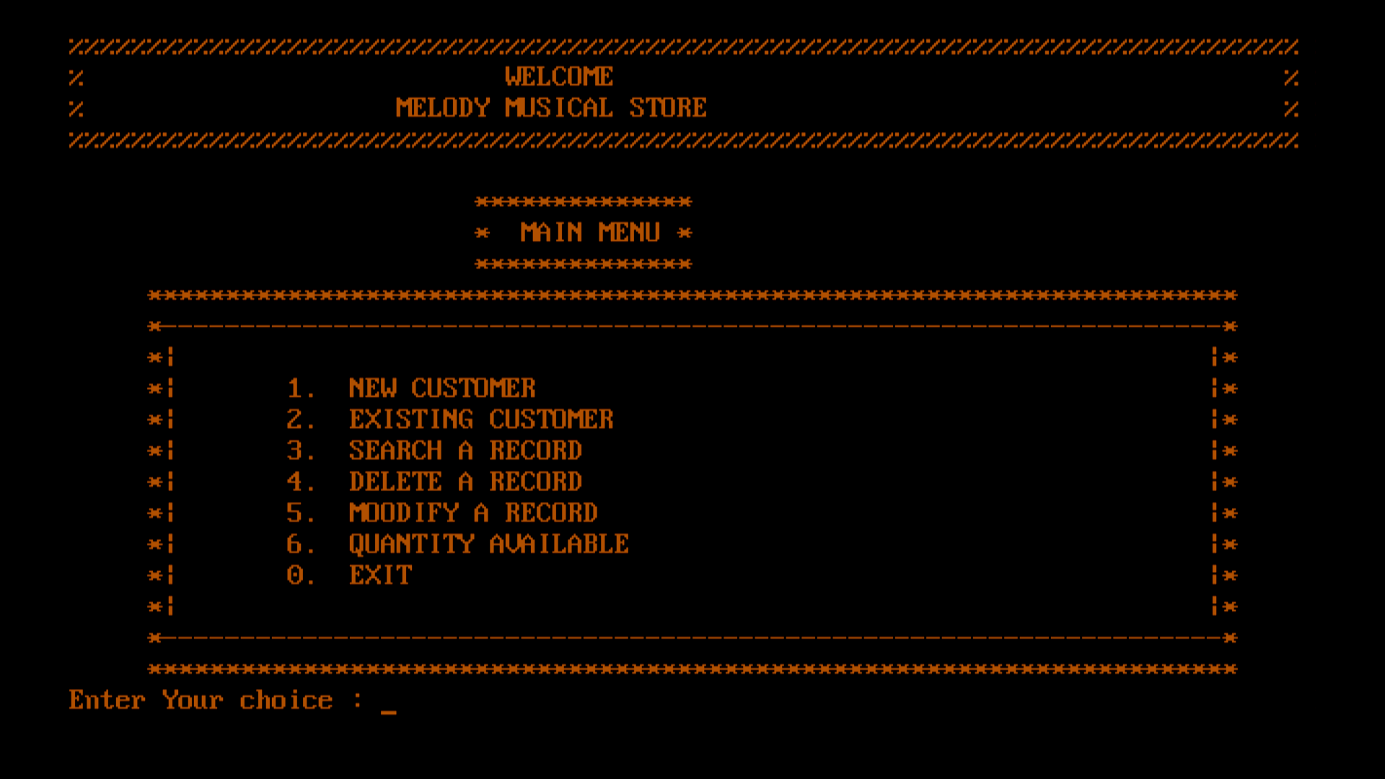

1.1 New Costumer Details Entry

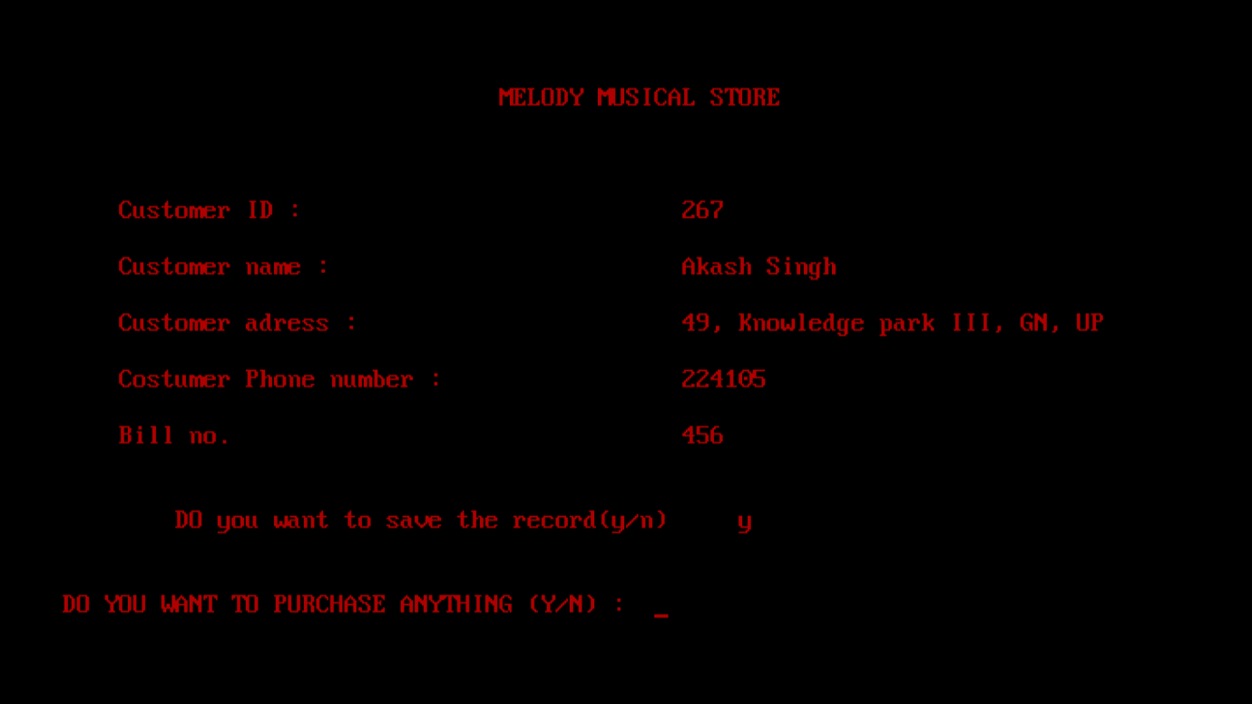

A. If purchased something then

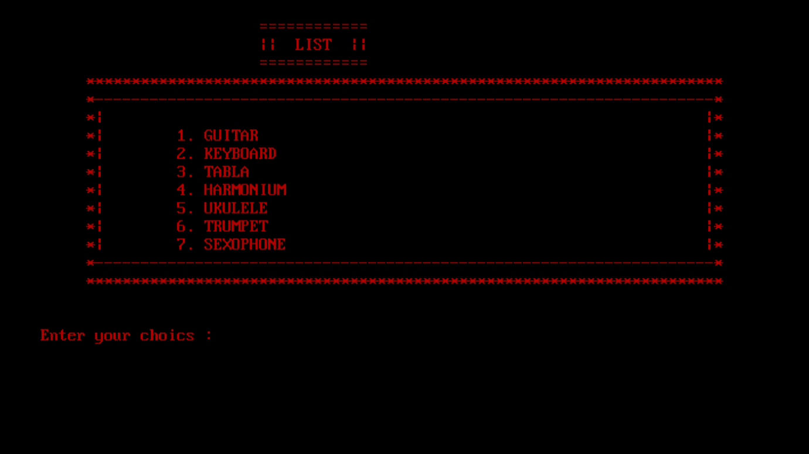

A.1 Guitar Section

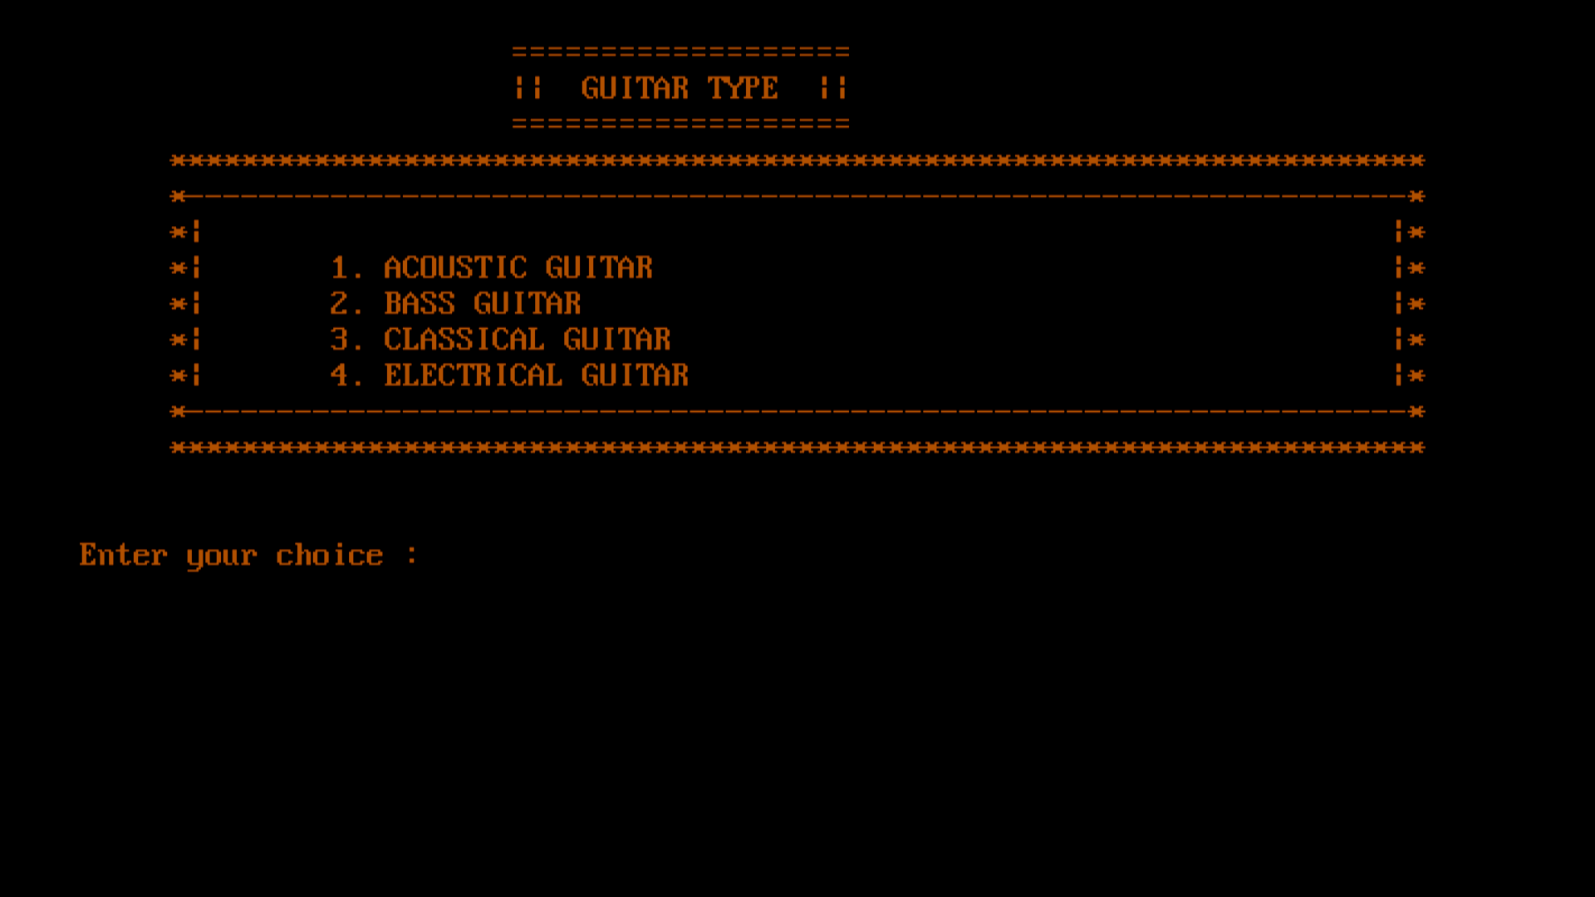

A.1.1. Acoustic Guitar Section

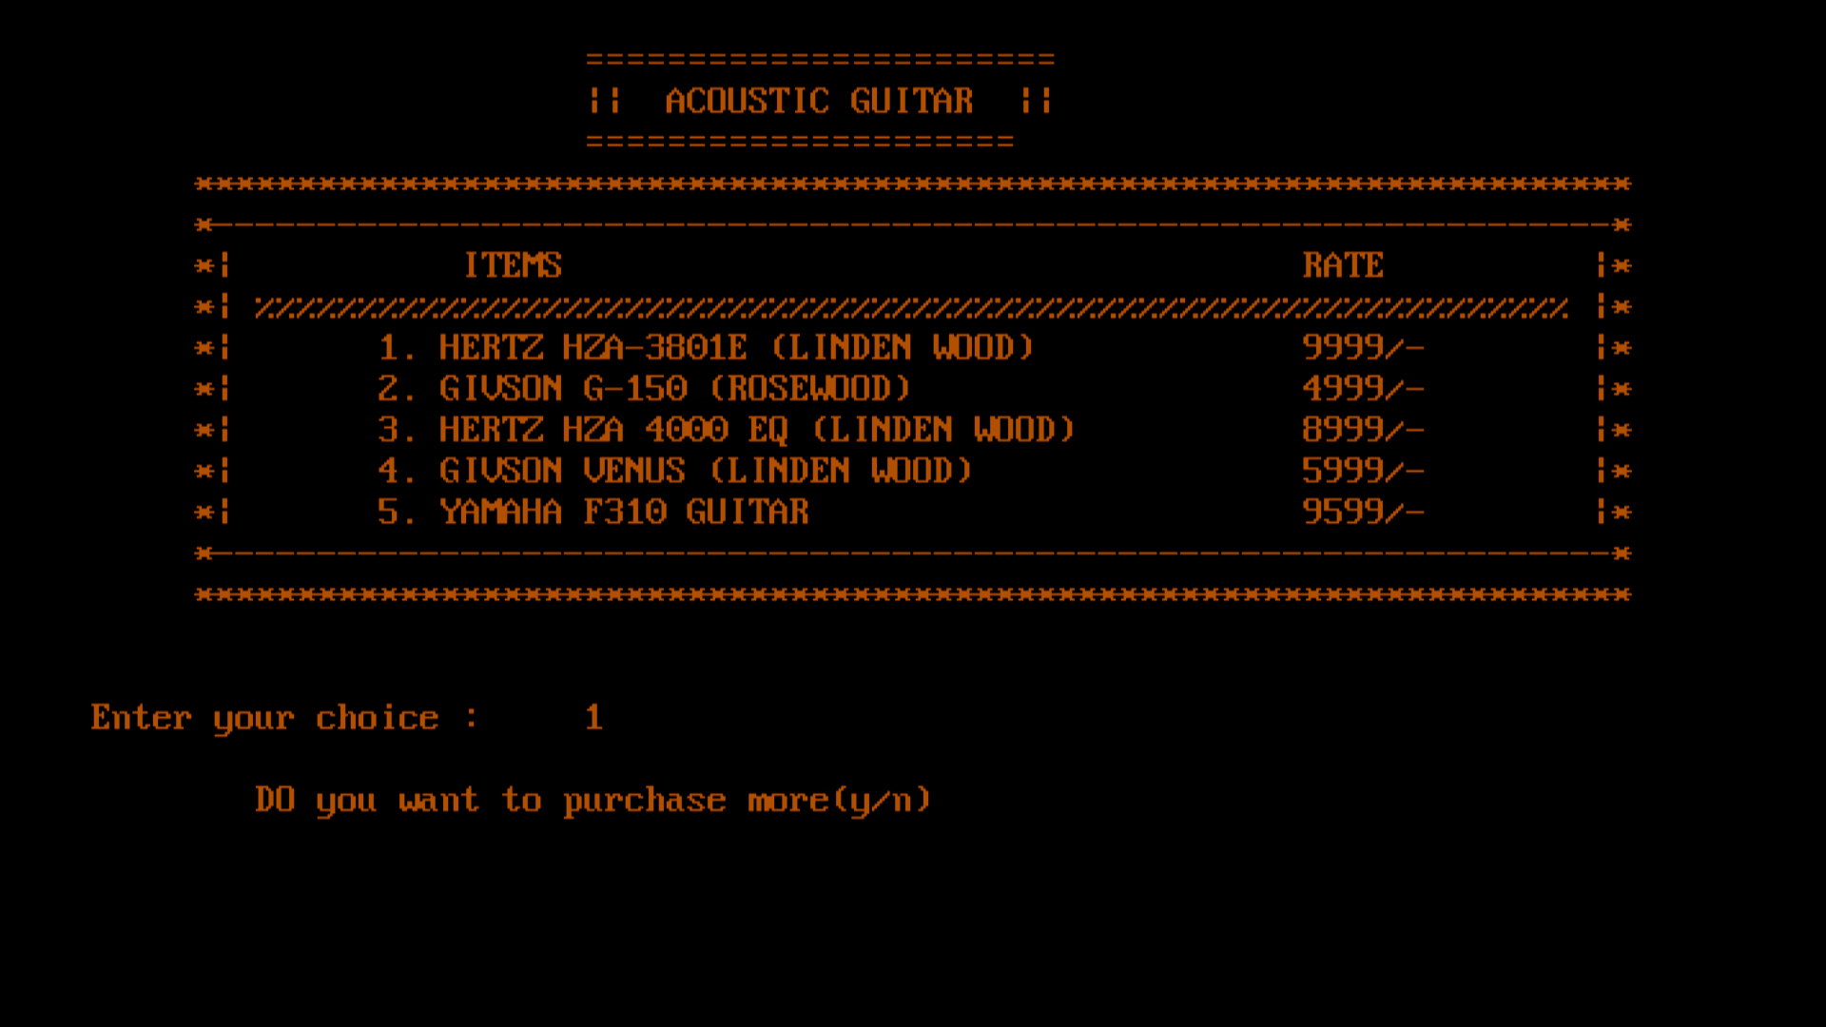

A.1.2 Bass Guitar Section

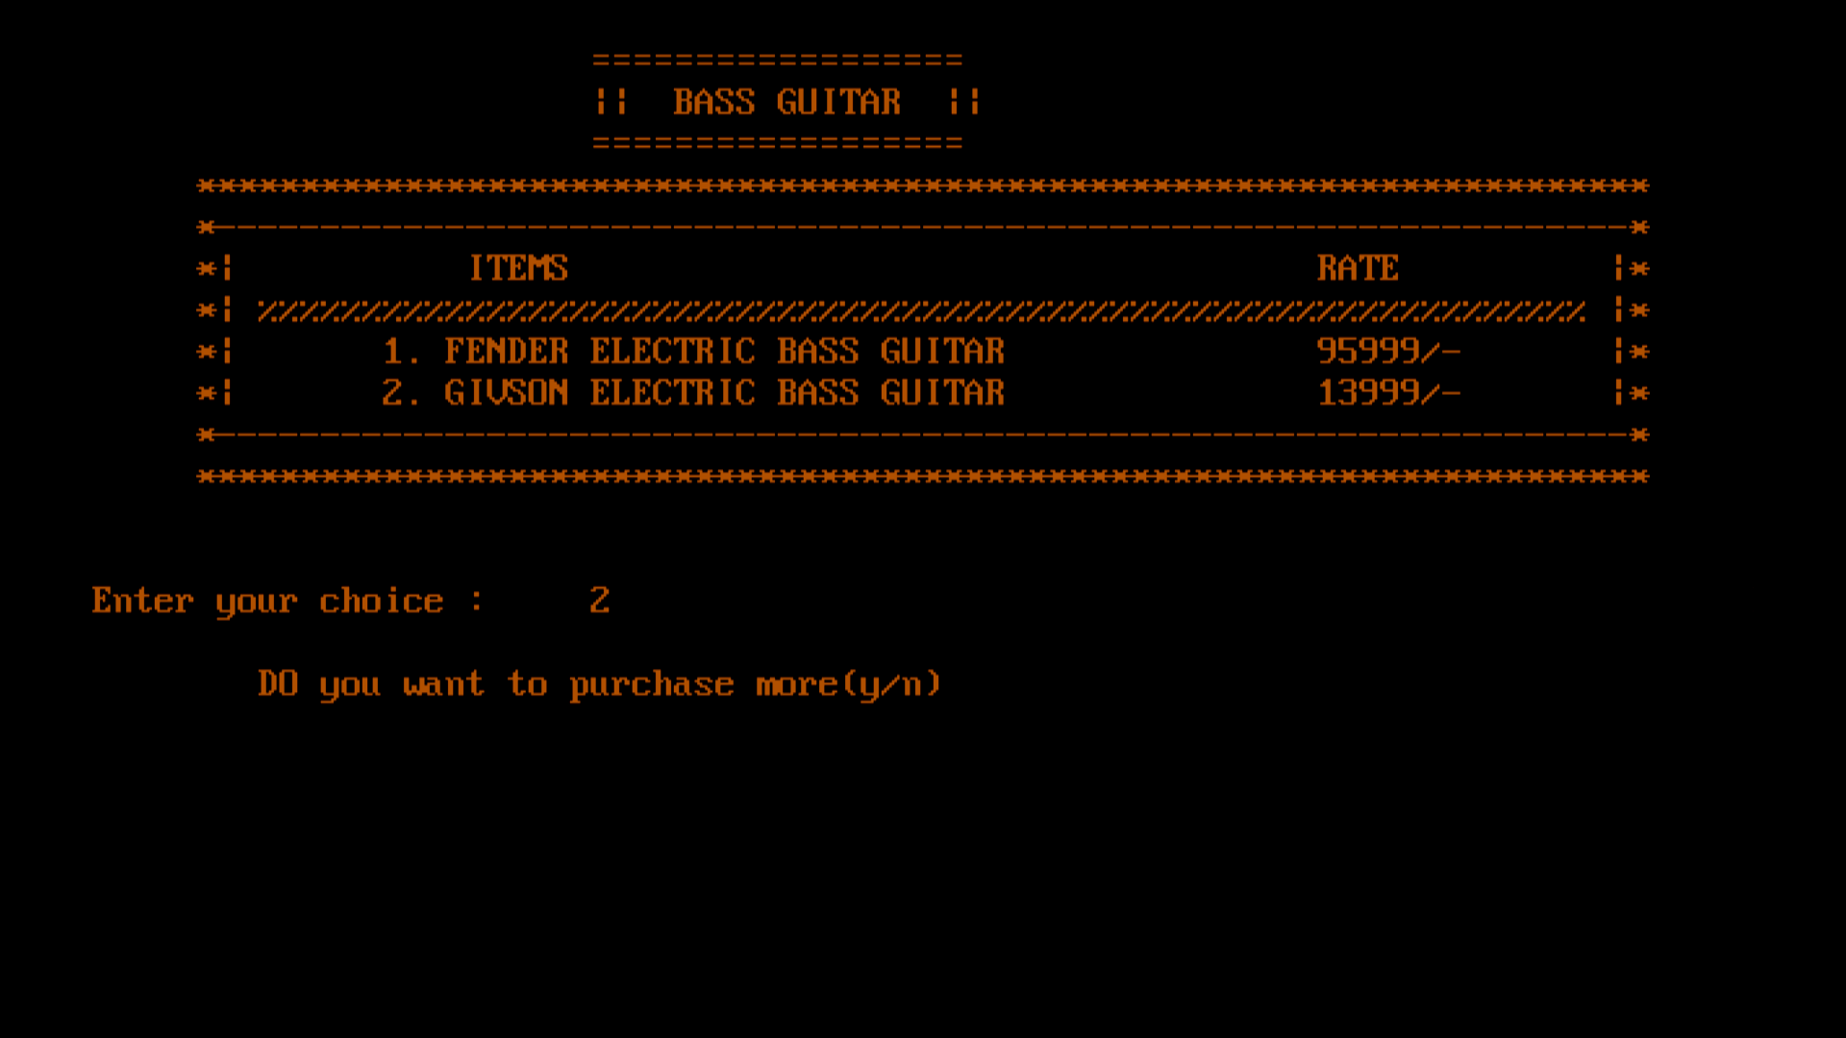

A.1.3. Classical Guitar

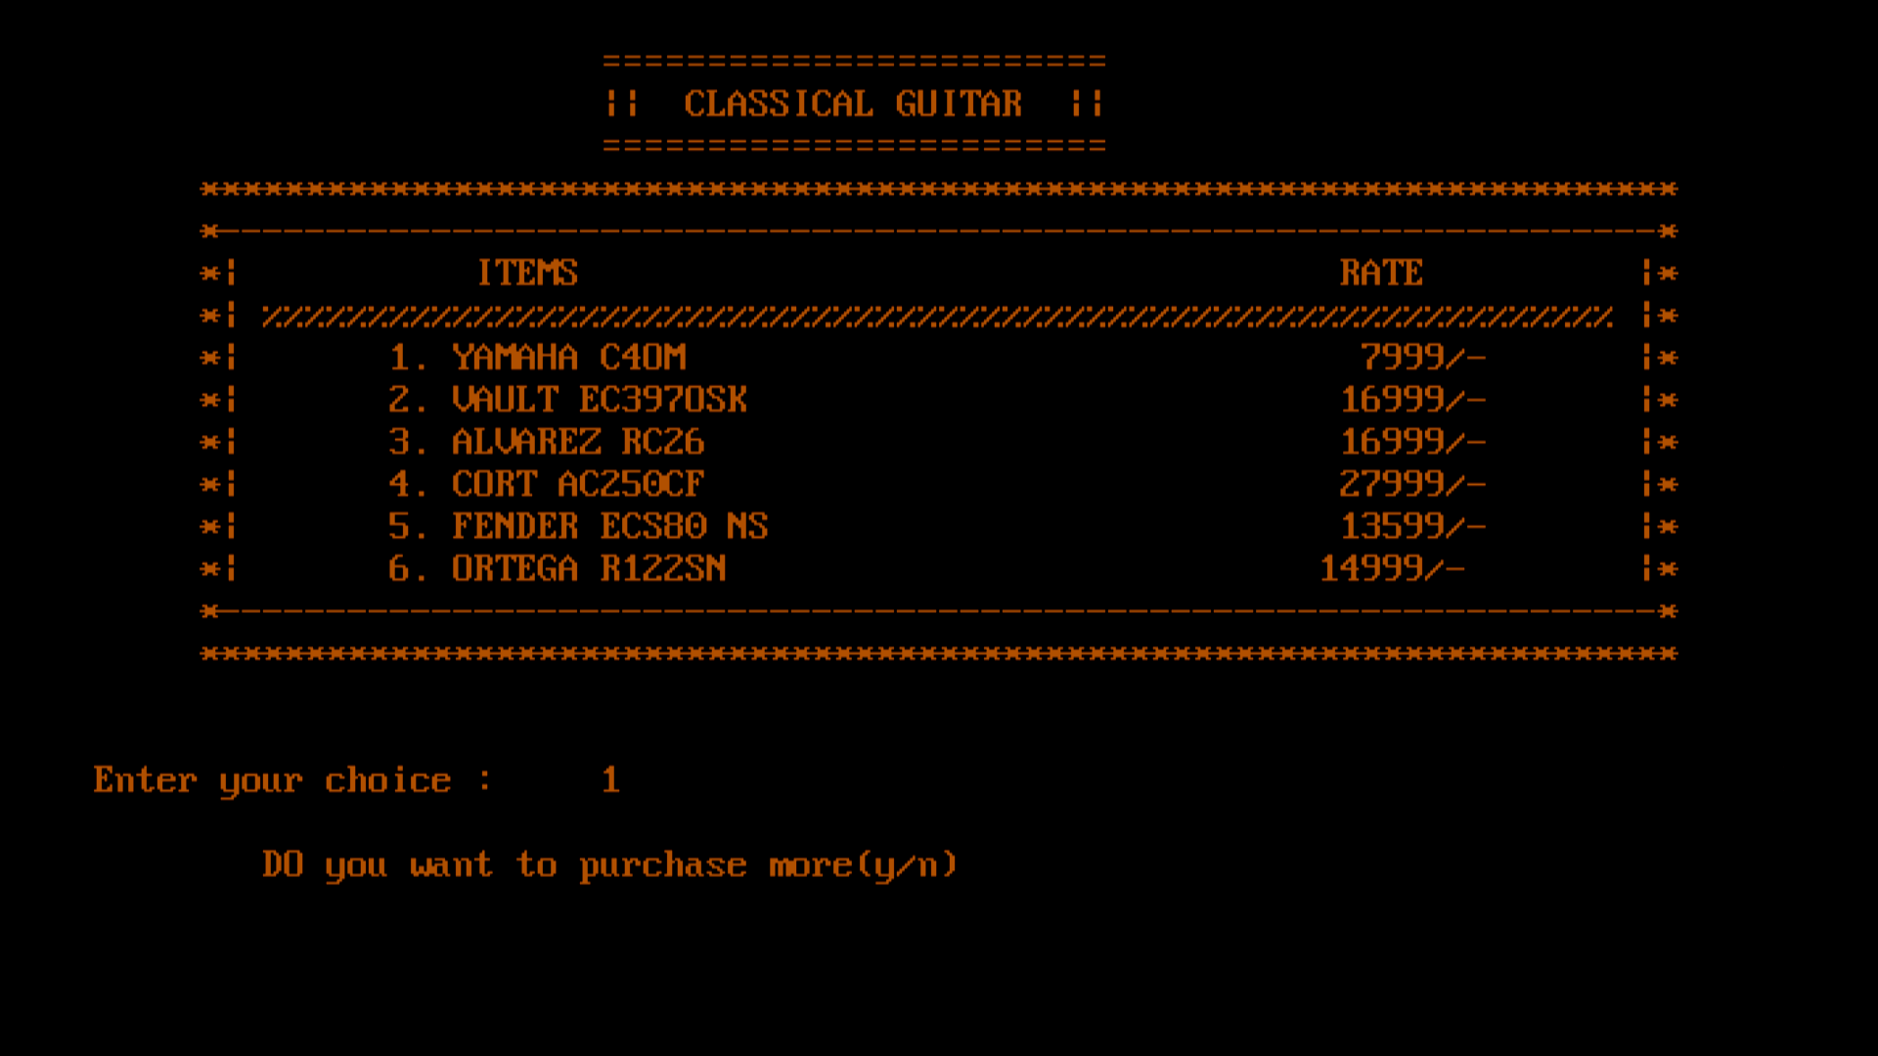

A.1.4. Electric Guitar

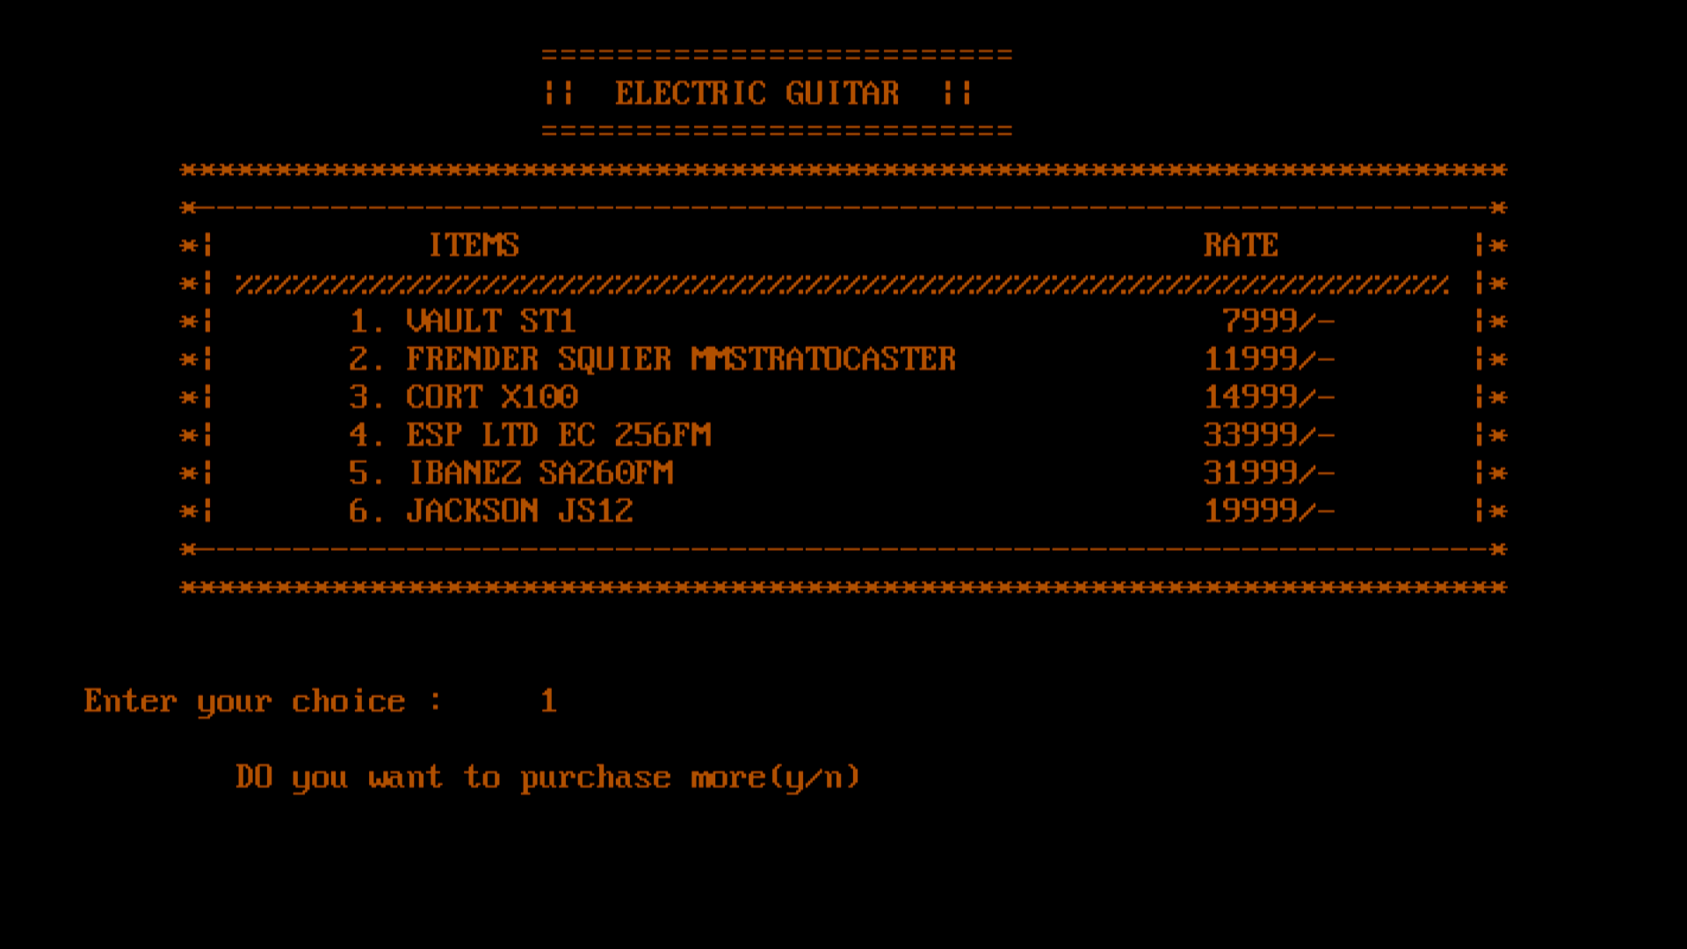

A.2 Keyboard Section

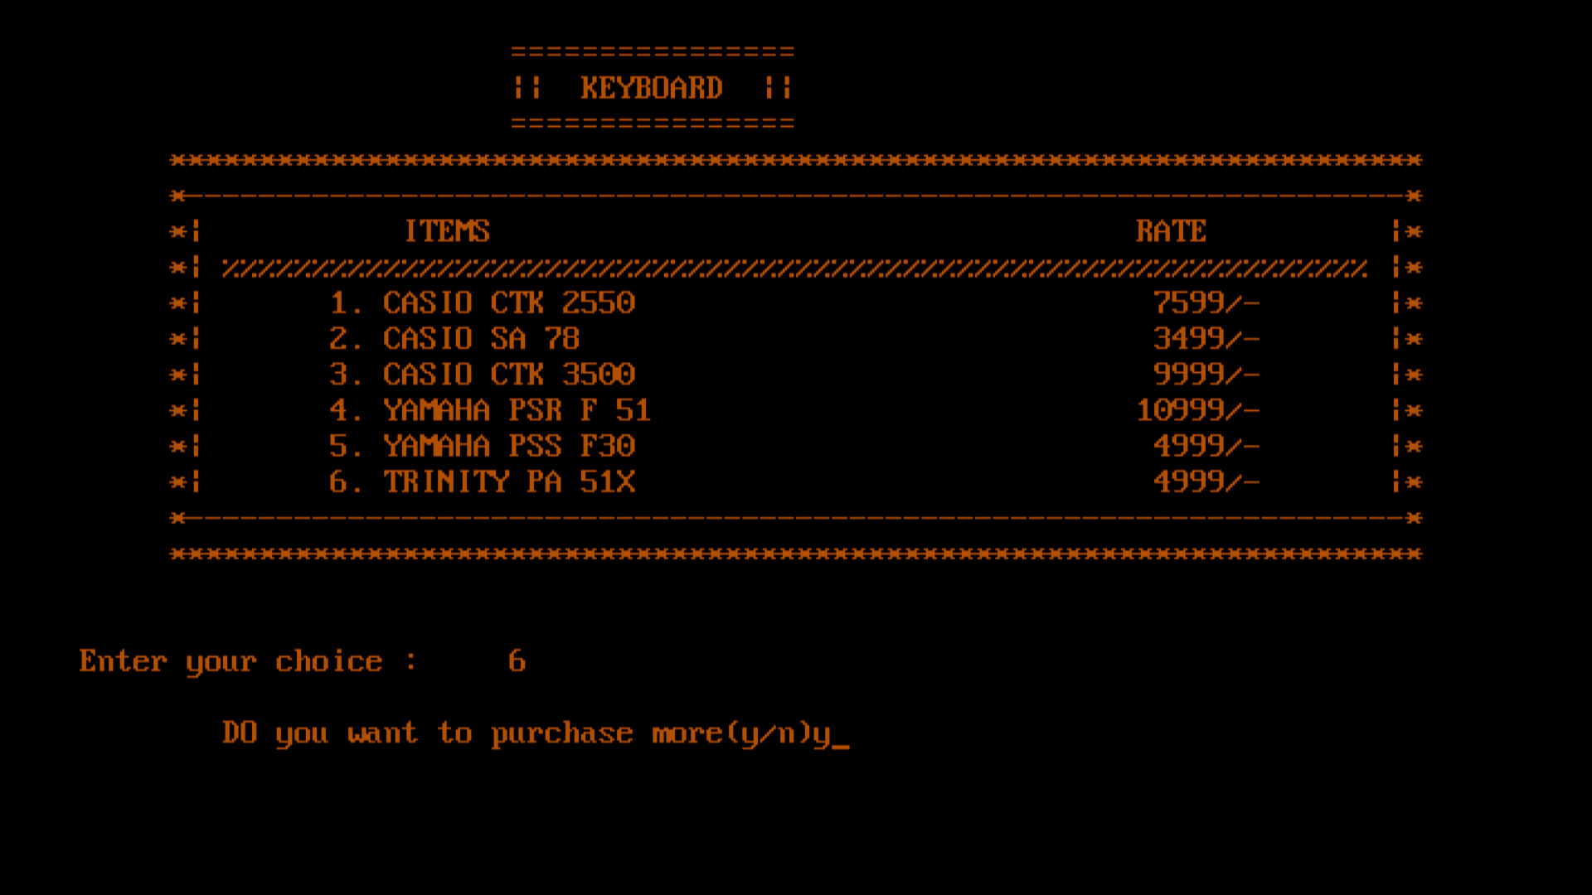

A.3. Tabla Section

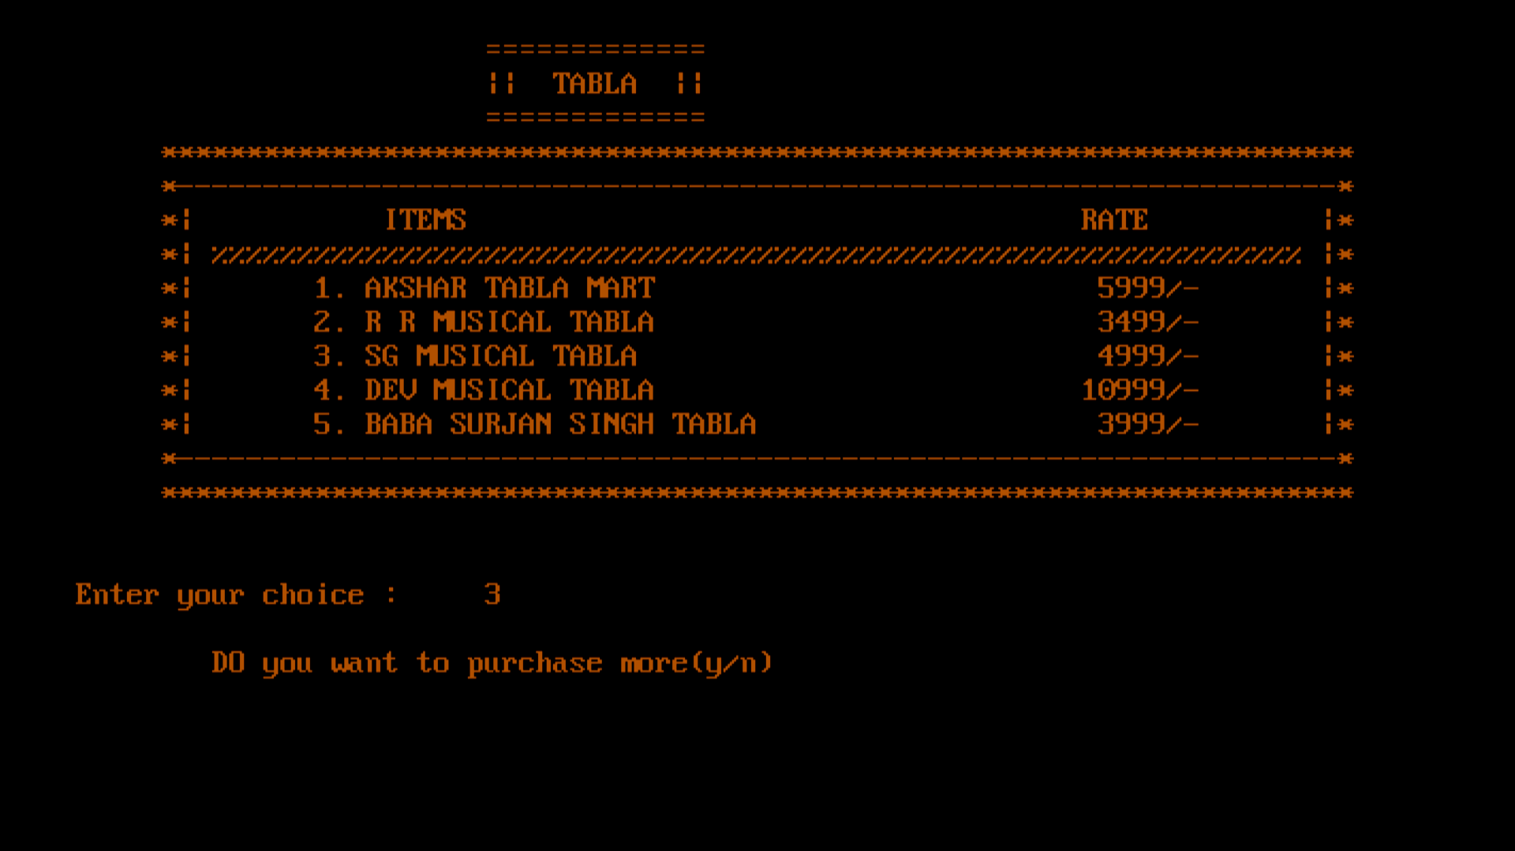

A.4. Harmonium Section

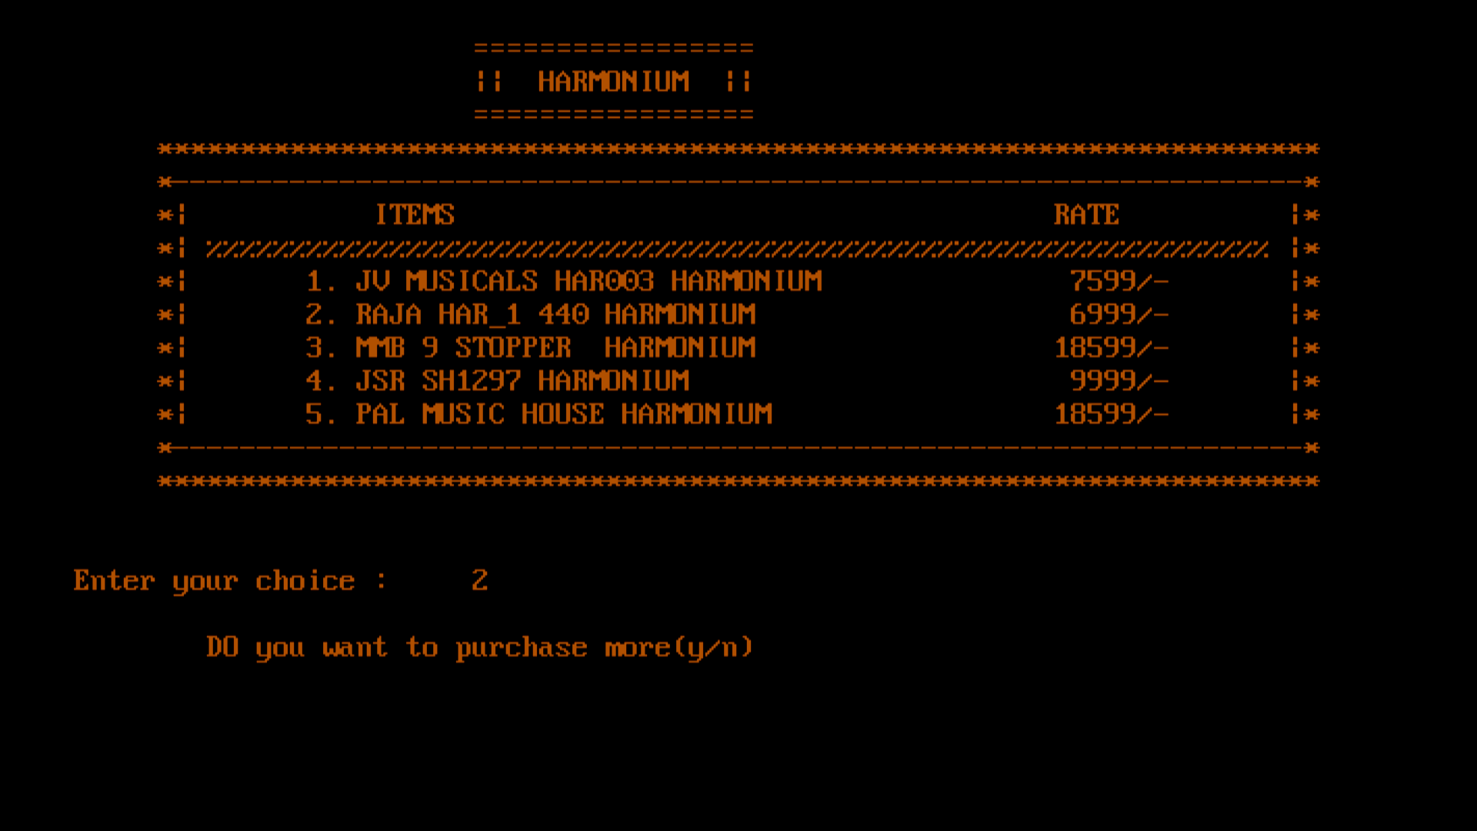

A.5. Ukulele

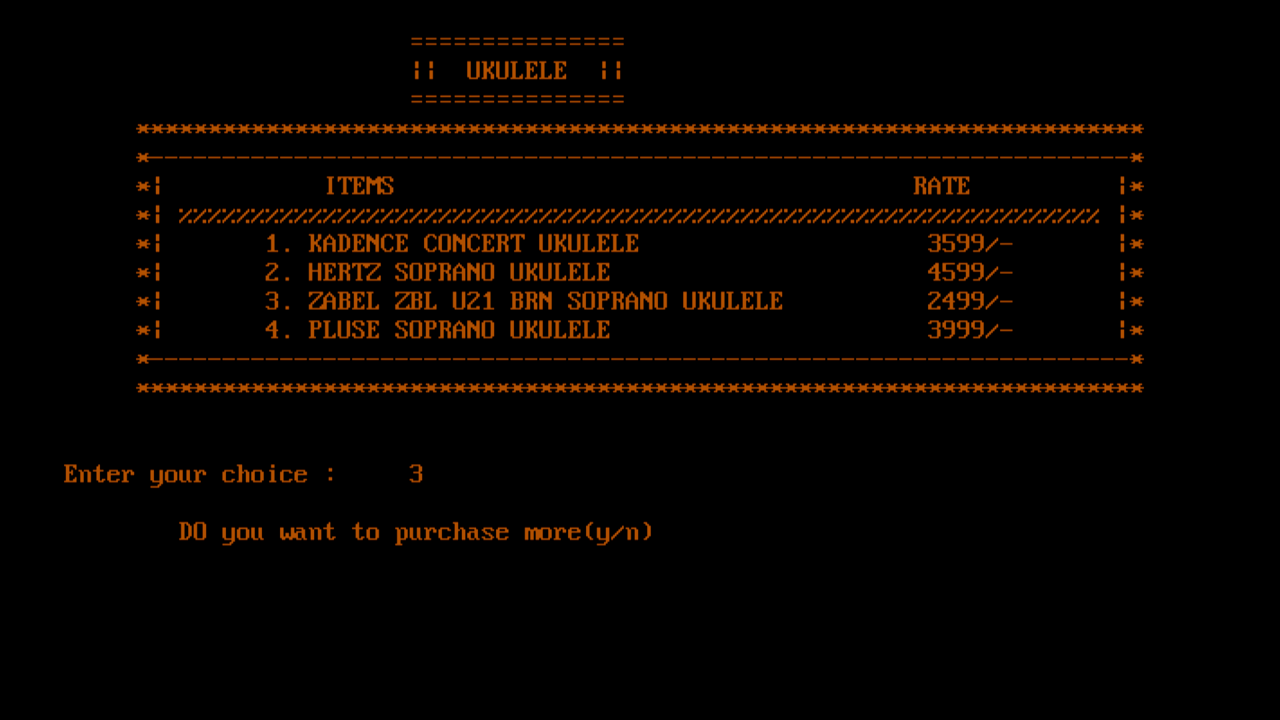

A.6. Trumpet

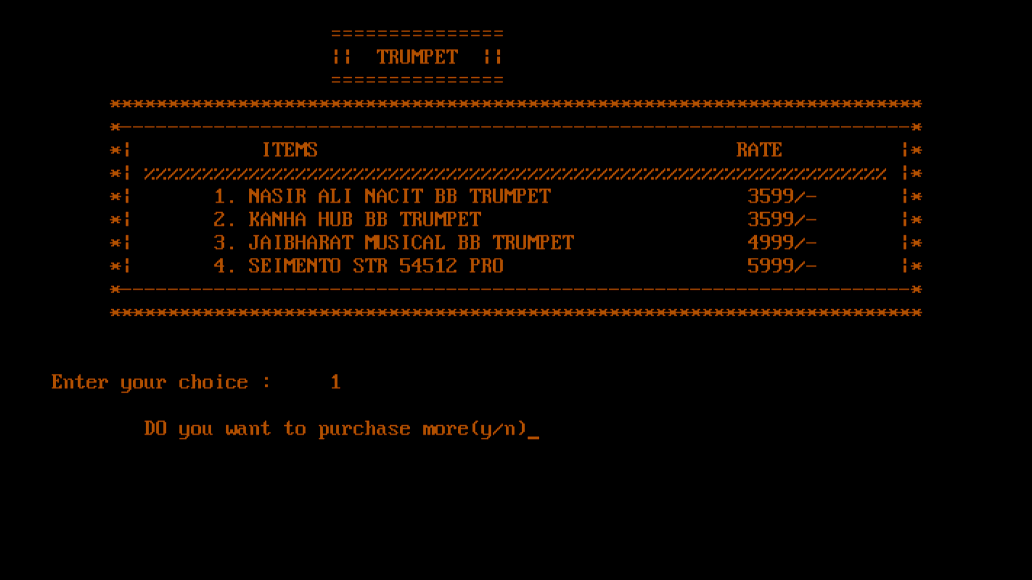

A.7. Sexophone

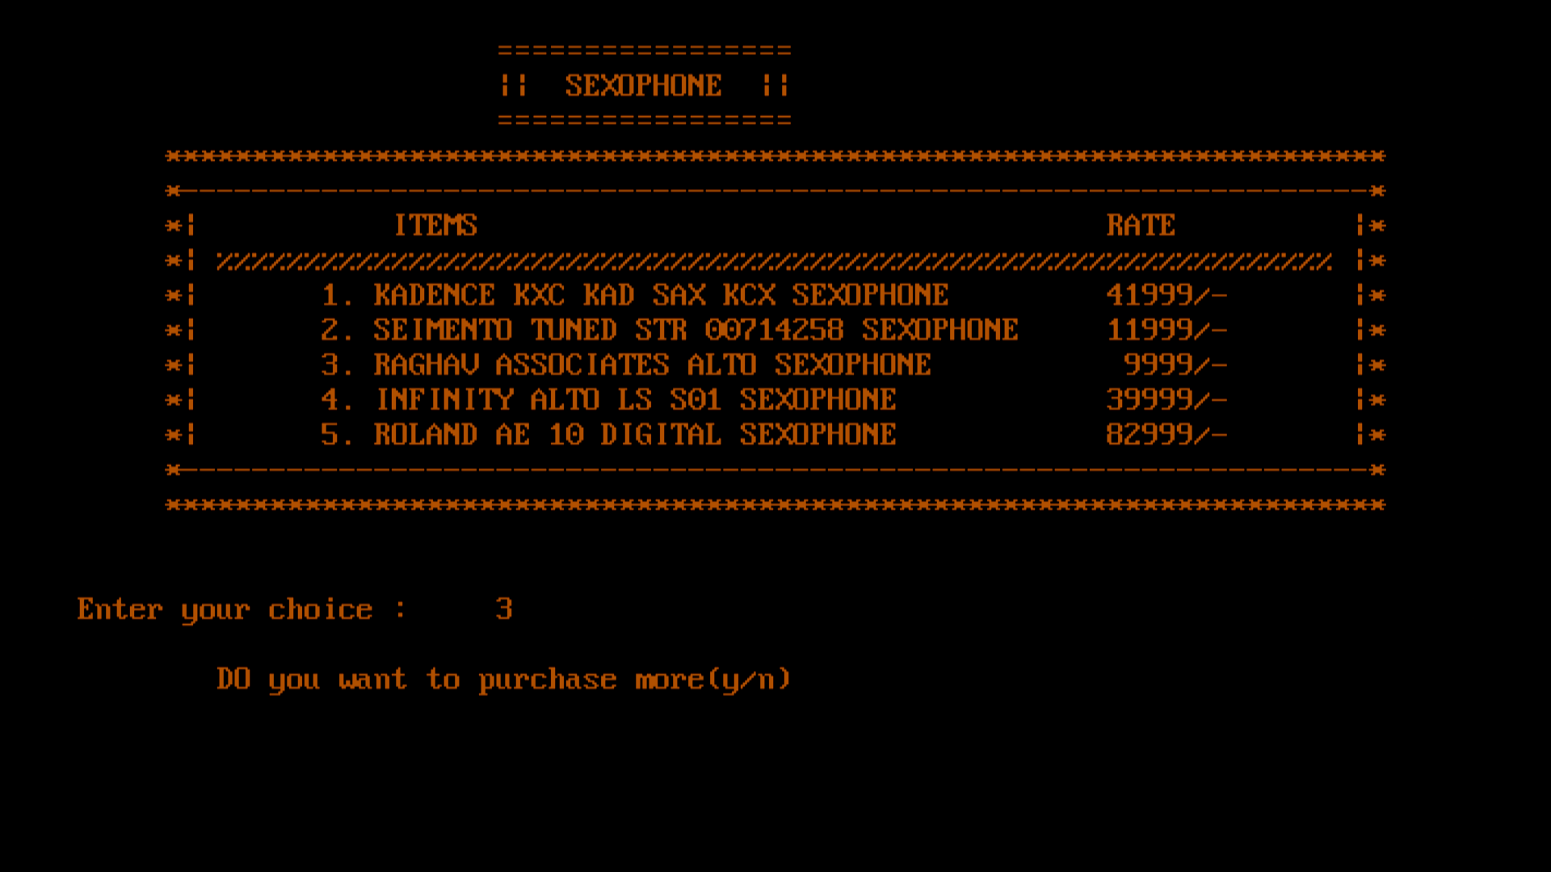

1. Purchased Items Cash Memo

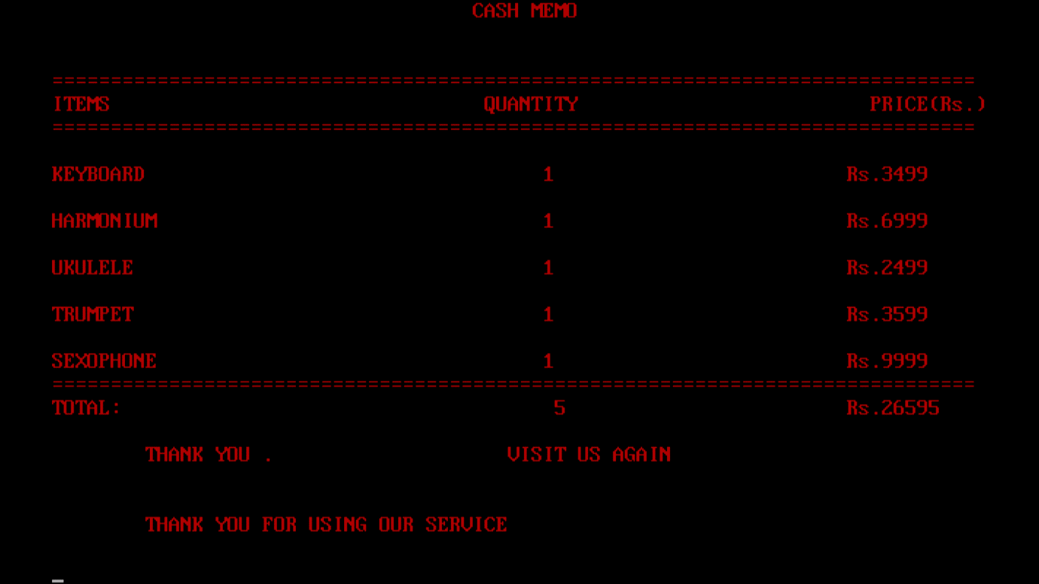

2. Existing Customer (if record found then purchase otherwise register 1st)

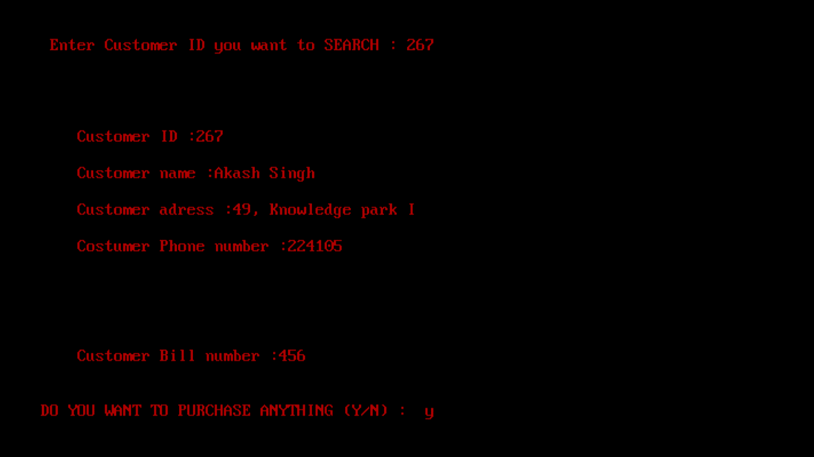

3. Search a Customer Details.

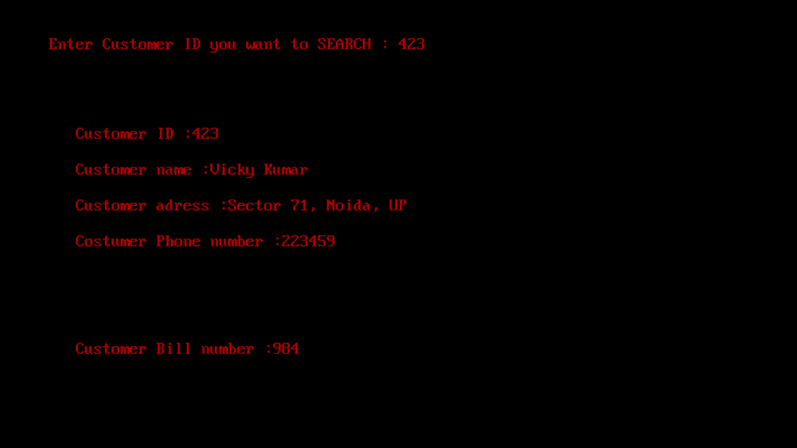

4. Delete a Customer Record.

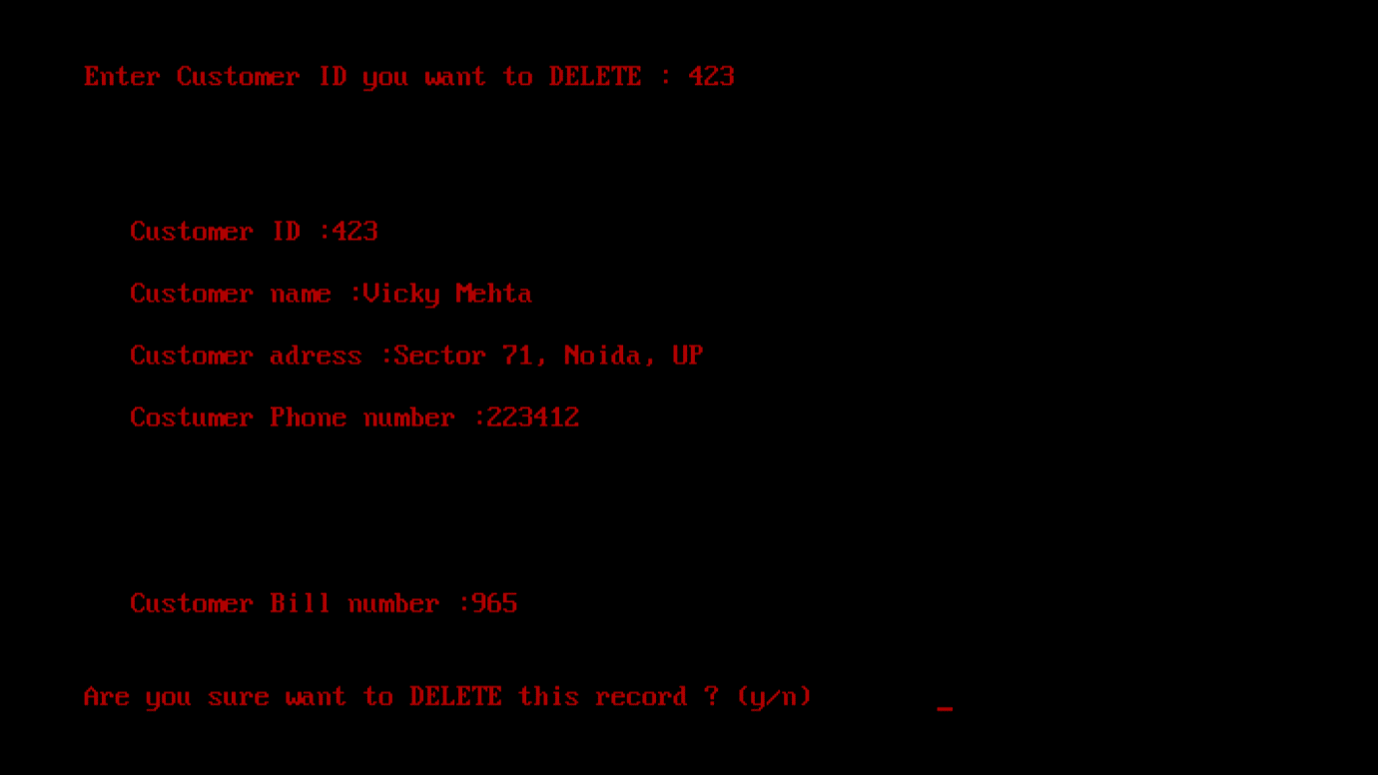

5.Update a Customer details

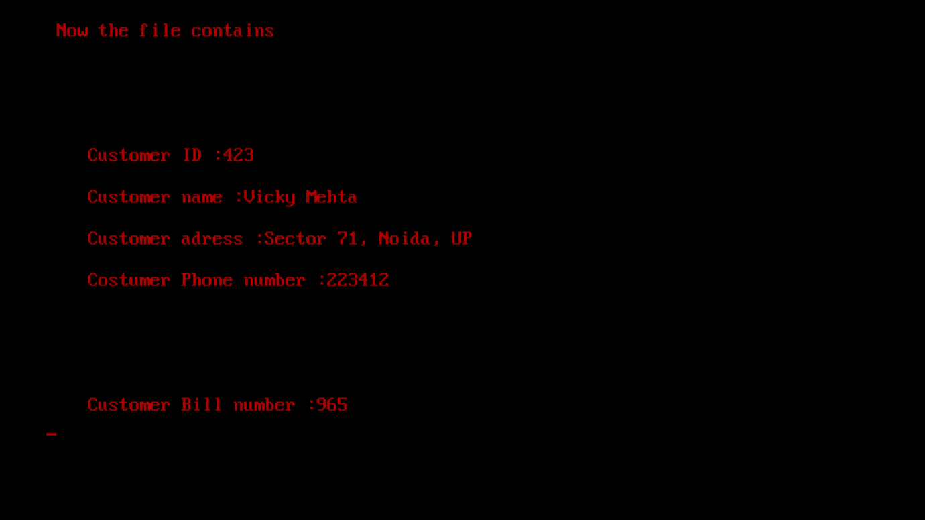

6. Quantity of Items Available.

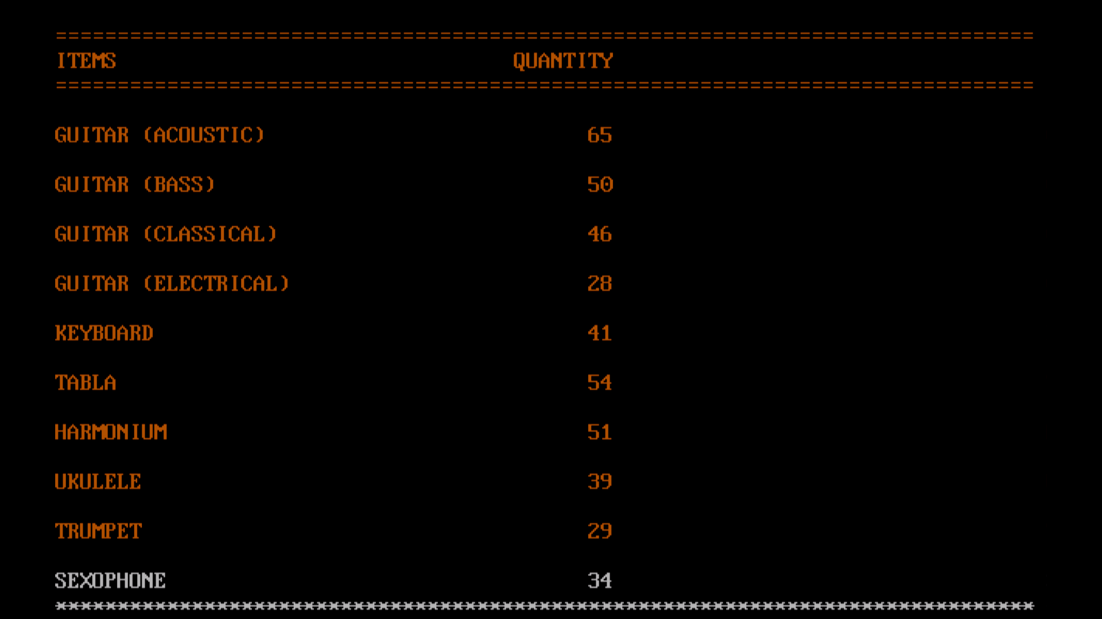

1. Exit

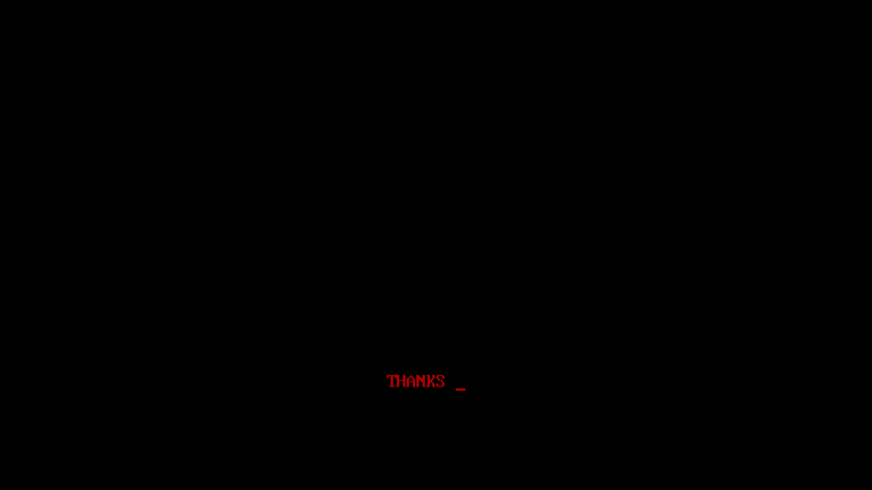

**FUTURE SCOPE**

1. This project will help the customer in fast reporting.

2.This project enable shop owner to maintain a great data base of all Customer ’ s details from the software.

1. Project will enable to see report regarding query.

1. It is easy to maintain in future prospect.

CONCLUSION

This was my project of System Design about “MUSIC SHOP MANAGEMENT SYSTEM ”.

Development of this System takes a lot of efforts. I think this system gave a lot of

satisfaction. Though every task is never said to be perfect in this development field even

more improvement may be possible in this system. I learnt so many things and gained a

lot of knowledge about development field. I hope this will prove fruitful.

## BIBLIOGRAPHY

1.Books referred = the complete reference 4 edition by Herbert schildt .

2. c/c++ programming book from pragya publication

3.Websites referred = [google.com , stackoverflow.com, geeksforgeeks.com , javatpoint.com.](https://d.docs.live.net/6d2043ff14082ee8/Documents/bank%20management%20code%20and%20output.docx)